

**School of Public Administration  
Bachelor of Science in Computing**

**COMP321 Information System Implementation  
Final Report**2013/14 2nd semester

|  |  |
| --- | --- |
| Online Shopping Mall | |
|  |  |
| Team number: | [8] |
| Team members: | [Key LIANG Yijuan (P1107923)]  [Mark MAK Chi Hou (P1104431)][Winson WONG Weng Io (P1104557)] |
|  |  |
| Supervisor: | [Calana Chan] |
| Assessor: | [Andrew Siu] |
|  |  |
| Submission Date: | Apr 17, 2014 |

**Table of Contents**

[1 Introduction 3](#_Toc384741413)

[1.1 Overview 3](#_Toc384741414)

[1.1 Objectives 3](#_Toc384741415)

[2 Background and Related Work 8](#_Toc384741416)

[2.1 Background 8](#_Toc384741417)

[2.2 Related Work 9](#_Toc384741418)

[3 System Design 13](#_Toc384741419)

[3.1 Data Modeling 13](#_Toc384741420)

[3.2 Dynamic Modeling 19](#_Toc384741421)

[4 System Implementation 21](#_Toc384741422)

[4.1 Platforms 21](#_Toc384741423)

[4.2 Architecture 21](#_Toc384741424)

[4.3 Module Design 22](#_Toc384741425)

[5 Results and Discussion 24](#_Toc384741426)

[5.1 Project Outcome 24](#_Toc384741427)

[5.2 Testing 32](#_Toc384741428)

[6 Conclusion and Further Work 38](#_Toc384741429)

[References 39](#_Toc384741430)

[Appendix 41](#_Toc384741431)

[Project plan 41](#_Toc384741432)

[Peer Assessment Form 43](#_Toc384741433)

# Introduction

Internet provides an opportunity for e-retailing business. Customers can do shopping in a wide range of products, but are not limited to office hours and transportation. Manufactures huge cost savings that can provide services for both large and niche markets are not running from the brick-and-mortar stores.

We have designed and developed an online shopping mall with types of goods including book, discs and game. Our website includes two major functions for both the customers and the vendor. The customers can browse and search product. Besides, they can see detail information about a product. They can also add or remove products to their shopping carts and can trace the processing status of their orders. By maintaining a product catalog in the shopping mall, the vendor can also process purchase some orders from customers. In conclusion, the outcome of our website is user-friendly. Customer who wants to buy products from our website can easily use it. Besides, we provide easy-to-use interface for vendor to insert new goods. It is convenient for all users to use our website in anytime and at anywhere.

## Overview

We are going to design and develop an online shopping mall with types of goods including book, discs and game. For the book type, it is separated to comic, novel, and magazine; for the discs type, it is differentiated into CD and DVD (including Blu-ray).

## Objectives

In our online shopping mall website, many functions are available for both the customers and the vendor. The customers can browse and search product. Besides, they can see detail information about a product. What’s more, they can create their new accounts. They can also add or remove products to their shopping carts and can trace the processing status of their orders. By maintaining a product catalog and product details in the shopping mall, the vendor can also process purchase orders from customers. The details of the functionalities are listed in the following paragraphs.

Customers

Customers do ‘window shopping’ in store frontend of the mall, browse and select desired products, and place orders for products in the shopping cart. The application supports the following functions.

A customer can browse and search product in product list.

(A1) A customer may browse products in a list of products. The list shows basic information of products, including product name, product category, price and a thumbnail image.

(A2) The product list supports paging. I.e. the customer can navigate the product list by ‘page up’, ‘page down’ and jumping to a specific page.

(A3) The customer may filter the product list by selecting one of the existing product categories.

(A4) The customer may filter the product list by searching keywords in product name.

(A5) The customer may filter by category and search keywords at the same time.

(A6) The customer may order the product list by price.

The product detail page shows detail information about one product.

(B1) The customer may select a product in the product list to go to the product detail page.

(B2) The product detail page shows the product name, product category, price and a thumbnail image. In addition, the product detail page also shows detail description as a list of properties. For example, the product detail page for a book shows authors, ISBN, publisher, release date and number of pages.

(B3) The customer can also go back to the product list with the browser ‘back’ button or a button in the product detail page. The product list must be in the same search status as before.

(B4) The product detail page supports display of more than one photo of the selected product.

(B6) The product detail page shows a list of related products.

The system has basic account management for customers. The product list and product detail page are accessible to customers before and after login. On the other hand, the shopping cart and purchase tracking functions are only accessible after login.

(C1) A customer may register a new account. She has to provide full name, email address, password and shipping address.

(C2) After a customer logs out and closes the web browser, another user cannot see any private purchase data of the customer by browsing the ‘history’ of the browser.

(C3) If a customer tries to access the shopping cart or purchase tracking before login, the system will redirect the customer’s browser to a login page, and then redirect it back to the shopping cart or purchase tracking page after successful authentication.

(C4) The customer can change password. There is strength requirement for password.

To make any purchase, a customer must add or remove products to her shopping cart. The customer can check out all items in the cart to place an order.

(D1) The customer adds a product to her shopping cart by clicking a button or link in the product detail page. The quantity to buy is assumed to be 1.

(D2) The customer can list the products in her shopping cart in a shopping cart page. In this page, the entry for each product shows the product name, price, a thumbnail image and the quantity to buy. The page also shows the total price of products in the shopping cart.

(D3) The customer can click an item in the shopping cart to go to the product detail page of the entry.

(D4) The customer can press a button in the shopping cart page to check out all items in the shopping cart. This action creates a purchase order, and clears the content of the cart.

(D5) The items in shopping cart are persisted after the customer logs out. Next time the customer logs in, she can still see the items in her shopping cart.

(D7) The customer can remove an item from the shopping cart.

After placing an order, the customer can trace the processing status of the order in a purchase tracking page. For simplicity, we assume that each purchase order is fulfilled in a single shipping package. The purchase order status describes the various stages of order processing. Possible values include ‘pending’, ‘shipped’ and ‘received’.

(E1) The purchase tracking page lists the current purchase orders, i.e. the purchase orders that the customer has placed, but has not received or cancelled. In other words, the status of purchase orders shown is either ‘pending’, ‘shipped’, or ‘hold’. The purchase tracking page shows, for each purchase order, the purchase date, the shipment date (if any), the total cost and the purchase order status.

(E2) The customer can expand an entry in the list of purchase orders to show a purchase order detail page. This includes, for each product in the purchase order, the product name, the quantity, the unit price and the subtotal. The detail page also shows the purchase date, the customer name, the shipping address, the total cost of the purchase order, and its purchase order status.

(E3) After receiving the purchased products from logistics service, the customer should confirm the receipt. In the purchase order detail page, the customer can click a button to confirm the receipt of all products in the purchase order. This will change the status of the purchase order from ‘shipped’ to ‘received’. Note that this action is only available for ‘shipped’ purchase orders.

Vendor

The vendor maintains a product catalog in the shopping mall. He can also process purchase orders from customers. Because there is only one vendor, the system only needs to implement a single vendor user account. No account management of vendor accounts is necessary in this project. The application provides the following functions.

Product catalog maintenance: The vendor can browse the product catalog, edit some properties of a product, and add new products.

(G1) The vendor may browse the product catalog in an interface similar to customers.

(G2) The vendor may search a product by category and keywords in product name.

(G3) The vendor may add a new product to the catalog. The vendor enters basic information of the product, including product name, product category, price and a thumbnail image.

(G4) In addition to the basic information, the vendor can enter detail information of the new product as a list of properties.

Purchase orders processing: The vendor can list ‘pending orders’ and ‘on-delivery orders’. He may ship, hold, or cancel a purchase order.

(H1) The vendor can list ‘pending orders’, which are purchase orders that are created when customers confirm purchases in their shopping carts. The status of ‘pending orders’ should be ‘pending’ or ‘hold’. The list of ‘pending orders’ shows purchase dates, customer names, total costs and purchase order status.

(H2) The vendor can expand an entry in the list of ‘pending orders’ to show a purchase order detail page. This page includes, for each product in the purchase order, the product name, the quantity, the unit price and the subtotal. The detail page also shows the purchase date, the customer name, the shipping address, the total cost of the purchase order, and its purchase order status.

(H3) In the purchase order detail page, the vendor can click a button to ship a purchase order. This action changes the status of the purchase order from ‘pending’ to ‘shipped’ and starts the shipping process.

(H4) The vendor can list ‘on-delivery orders’, which are purchase orders that are shipped, but the customers have not confirmed receipt yet. The status of ‘on-delivery orders’ should be ‘shipped’. The list of ‘on-delivery orders’ shows purchase dates, shipment dates, customer names, total costs and purchase order status.

This report is organized as follows: Chapter 2 introduces the background of our work. Chapter 3 presents our design approach. Chapter 4 shows the implementation details. Chapter 5 displays our results and discussions. Chapter 6 explains the conclusion and the further work.

# Background and Related Work

## Background

Internet provides an opportunity for e-retailing business. Customers can do shopping in a wide range of products, but are not limited to office hours and transportation. Manufactures enjoy huge cost savings that can provide services for both large and niche markets without the need of running the brick-and-mortar stores. Online shopping websites such as Amazon and Gamers are some successful examples.

For example, Amazon website [1] has many features. The home page has four main parts in the navigation bar. They are category searching, keywords searching, account service and cart viewing. At the category searching, each category has their subcategories. At the keywords searching, it can show the keyword candidates. At the account service, it has the login function. After login, the user can read his/her personal information and he/she can check his/her order history. At the cart viewing, user who has not logged in the website can also view the temporary cart list. It has recommended products based on different conditions in the content of home page. The conditions are “related items of viewed items” meaning products that are related to some products having been bought before, “pay attention to” meaning those products that are the hottest now, and “recommended from the browsing history” meaning those products that have been viewed before. There are many links of sub functions and links of different regions of amazon in the footer.

In each product list page [2], there are various ways to find the product that the user wants. The conditions include release date, sub categories, author, publisher, format, etc. Besides, the user can use the advanced search to enter some information to easily find the product that he/she wants. What's more, he/she can also sort the products by popularity, price up/down and release date new/old.

The product pages [3] contain image and information of the product. The page also contains a list of products bought by users who have bought the product of a page. What’s more, it has the customer review that he/she marks a score and writes a comment. In addition, the user can choose the quantity and click the cart in button to add the product to the cart.

In the shopping cart page [4], it shows the cart list and a user can click the checkout button to check out the content of the cart. However, if he/she has not logged in, he/she must log in before he/she can check out the cart.

For users who have not registered in the website, he/she needs to input the customer name, email address and the password in the register page [5] to complete the registration process.

In the account page [6], the customer can use services. First, order history is a service that he/she can search the purchase orders he has made. He/she can also confirm or change an order that has not yet completed. Besides, he/she can check the order which is not shipped. Second, the payment method setting is a service that he/she can add a new credit card. He can change or delete the credit card information. Besides, he/she can check the balance and usage history. What’s more, he/she can check his/her points. Third, account setting is a service that he/she can change his/her basic information and the password. He/she also can add a personal address. Besides, he/she can apply to become a special member. Fourth, download is a service that he/she can download e-book, MP3 music and video with payment. Last, service setting is a service that he/she can create or edit his/her profile. Also he/she can set the product recommendation view and see the customer reviews that he/she has posted.

## Related Work

This project focuses on facilitating the online shopping experience. Most of the functional requirements are about browsing and maintaining the product catalog, and placing and processing purchase orders.

To limit the scope, this project omits payment processing and inventory management. The delivery process is assumed to be instantaneous. Right after a vendor ships a purchase a customer receives the purchase and can confirm the receipt in the online mall.

The home page of our website shows a lot of recommended products. User can choose different categories for recommending which is not available in Amazon [1]. We also provide searching product by keywords. User also can simply select a category to search all the products in that category just like other websites. The search page lists 5 products per page and user can page-down or page-up to view more results. User can also search product by using keywords and category together. User can sort search result by price down as well. These functions are supported by other similar websites.

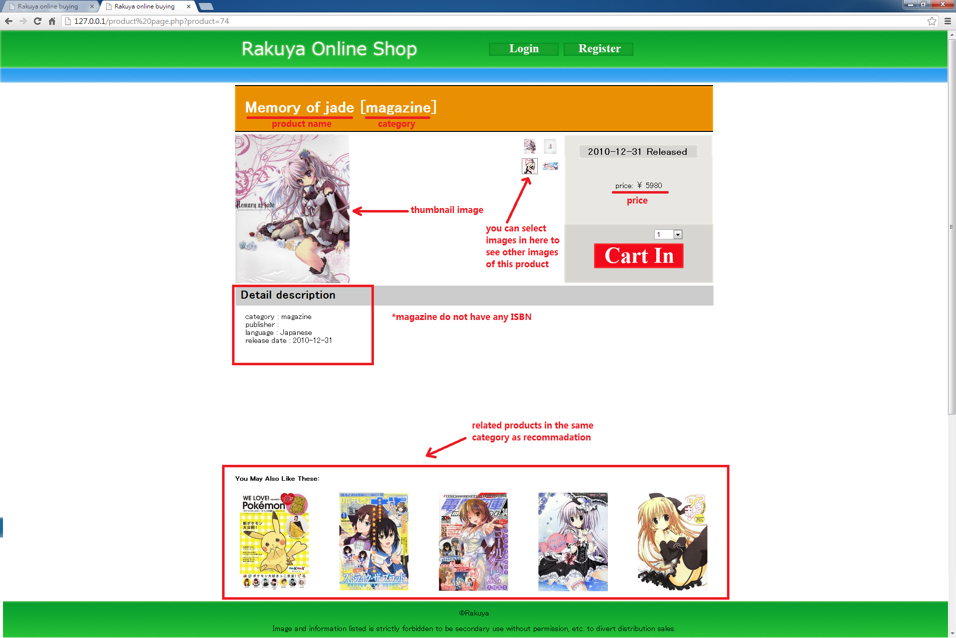

*Figure 1 Product Page*

As shown in Figure above, in the product details page, user can see the product name in the title, and category is written in title with square bracket. And in this page, user can see a thumbnail image of the product on the left hand side and can select other available image in the middle to view. However, we do not support picture enlargement. On the right hand side, user can know released date and price easily. Besides, user can click a ‘cart in’ button to add this product into his/her shopping cart. If a user has not login, we will redirect him/her to login page. After successful login, the cart page will be displayed and the user can see that the product has already been added to his/her cart. User can choose quantity he/she wants to add to cart. Under the image, user can view some detailed description of the product he/she is viewing. Moreover, we have a recommendation area to recommend user some more products that he/she may be interested in.

Similar to other webpages, there is a register page for user to become members of our shopping mall. After that, he/she can login to his/her account. Once user logins successfully, he will be redirected to the previous page he/she is viewing. If user types incorrect login information, an error message will be displayed and a ‘previous page’ button will allow user to go back to the previous viewing page.

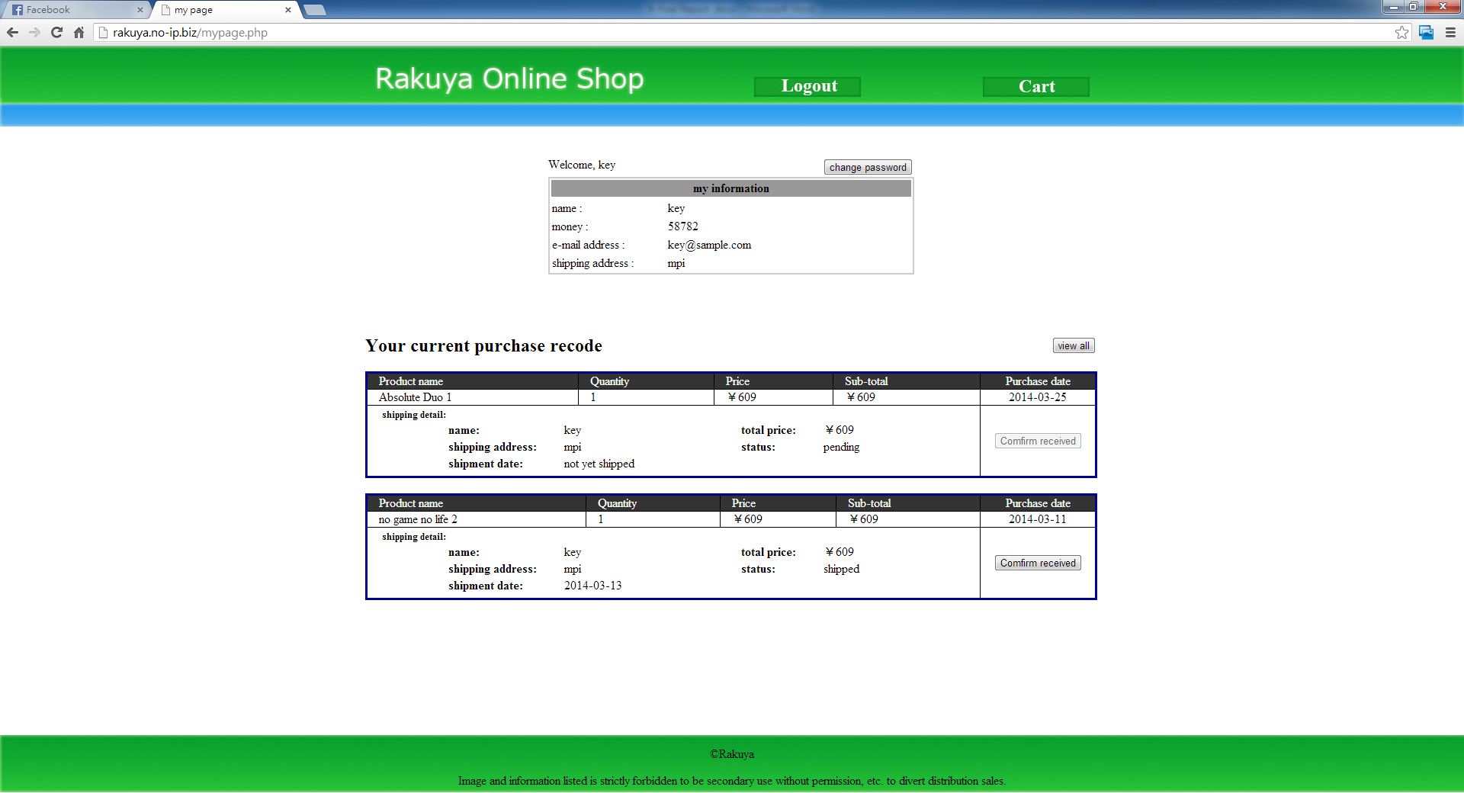After user login successfully, user can go to ‘my page’ to view his/her personal information as most online shopping websites. He/she can press ‘change password’ button to change his/her password. And under user profile, all of his/her orders will be listed. Unlike other similar online shopping websites, we simply list all the user’s orders in one page without paging being supported. In addition, user basic information is not allowed to do any changes. What’s more, current order, which means purchase orders not yet received, will be shown at once. If user wants to view all his/her purchase records including orders that have been confirmed, he/she can click the view all button.

**Press this button**

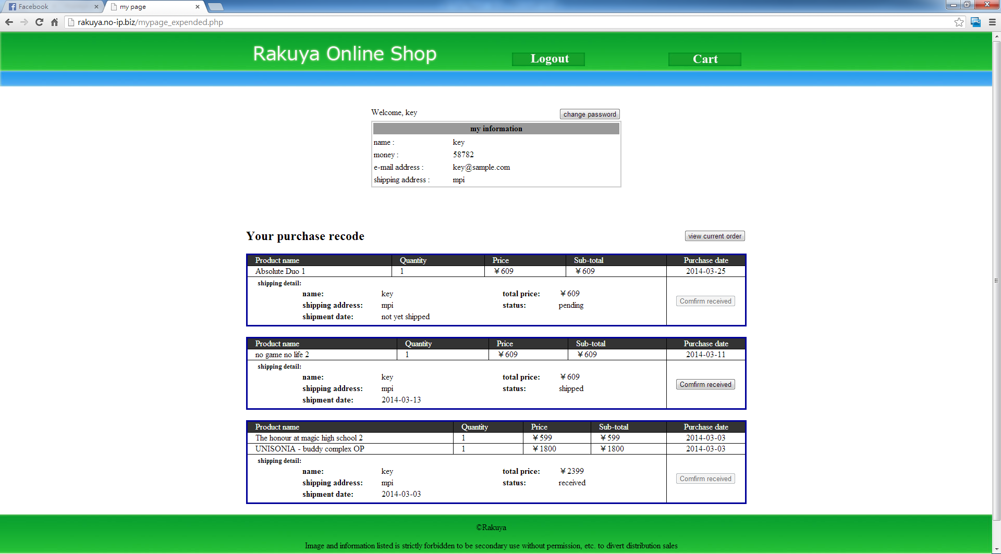

*Figure 2 My Page change order list view*

**View All Orders**

For logout, once user pressed logout he will be redirected to the login page.

Like most other similar online shopping websites, we allow vendor to add product and manage purchase orders. There is just one vendor in our online shopping mall. Vendor cannot go back to the any product view page unless he/she logout. In vendor mode, vendor can insert at most 10 products each time, compulsory information includes product name, category, price, image’s URL is needed. He can also input publisher, language, label, ISBN, EAN, time, discs, pages, release date if there are any. If the field has no information to fill in, the default input is ‘NULL’, otherwise, it may lead to error. However, once vendor inserted product information, he/she cannot make any changes and no such function is supported in our website. Besides, vendor can select ‘order’ view on the blue bar to view all pending orders, shipped orders or received orders. This view will be set to view pending order list by default. Vendor can switch to different lists by choosing it on the left top corner. When vendor is viewing pending order, he/she can press ‘View Detail’ to see more detailed information and change order status to ‘shipped’ if needed. Status includes ‘pending’, ‘shipped’ and ‘received’. Once a customer checkout his/her cart, he/she will have a new order with the default status ‘pending’. After the order is created, vendor can view it in vendor order list view. He/she is allowed to change order status to ‘shipped’ when the order is in pending list. And once the order status in change to ‘shipped’, the customer can press ‘confirm received’ button to confirm, and the order status will be changed to ‘received’. In other cases, neither vendor nor user can change order status.

# System Design

## Data Modeling

After analyzing the data requirement, our system has the following entities in the database.

**Product**product ( pid, pname, category, price)

pimage ( pid, imageURL)  
FK pid references Product(pid)

**Category**comic( pid, category, pages, publisher, language, ISBN, releaseDate) FK pid references Product(pid)

novel( pid, category, pages, publisher, language, ISBN, releaseDate)  
FK pid references Product(pid)

magazine( pid, category, publisher, language, releaseDate)  
FK pid references Product(pid)

music( pid, category, discs, label, EAN, releaseDate)  
FK pid references Product(pid)

DVD( pid, category, publisher, discs, releaseDate, time)  
FK pid references Product(pid)

game( pid, category, releaseDate)  
FK pid references Product(pid)

**User**user ( a\_name, pw, name, email, money)

userAddress ( a\_name, address)   
FK a\_name references User(a\_name)

shoppingcart ( a\_name, pid, qty)   
FK a\_name references User(a\_name)  
FK pid references Product(pid)

**Order**order ( order\_no, a\_name, purchaseDate, shipDate, status, total\_price)

orderDetail ( order\_no, pid, qty, price)  
FK pid references Product(pid)  
FK order\_no references Order(order\_no)

**ER-diagram**

Shown below is the ER diagram to represent the relationship among the entities.

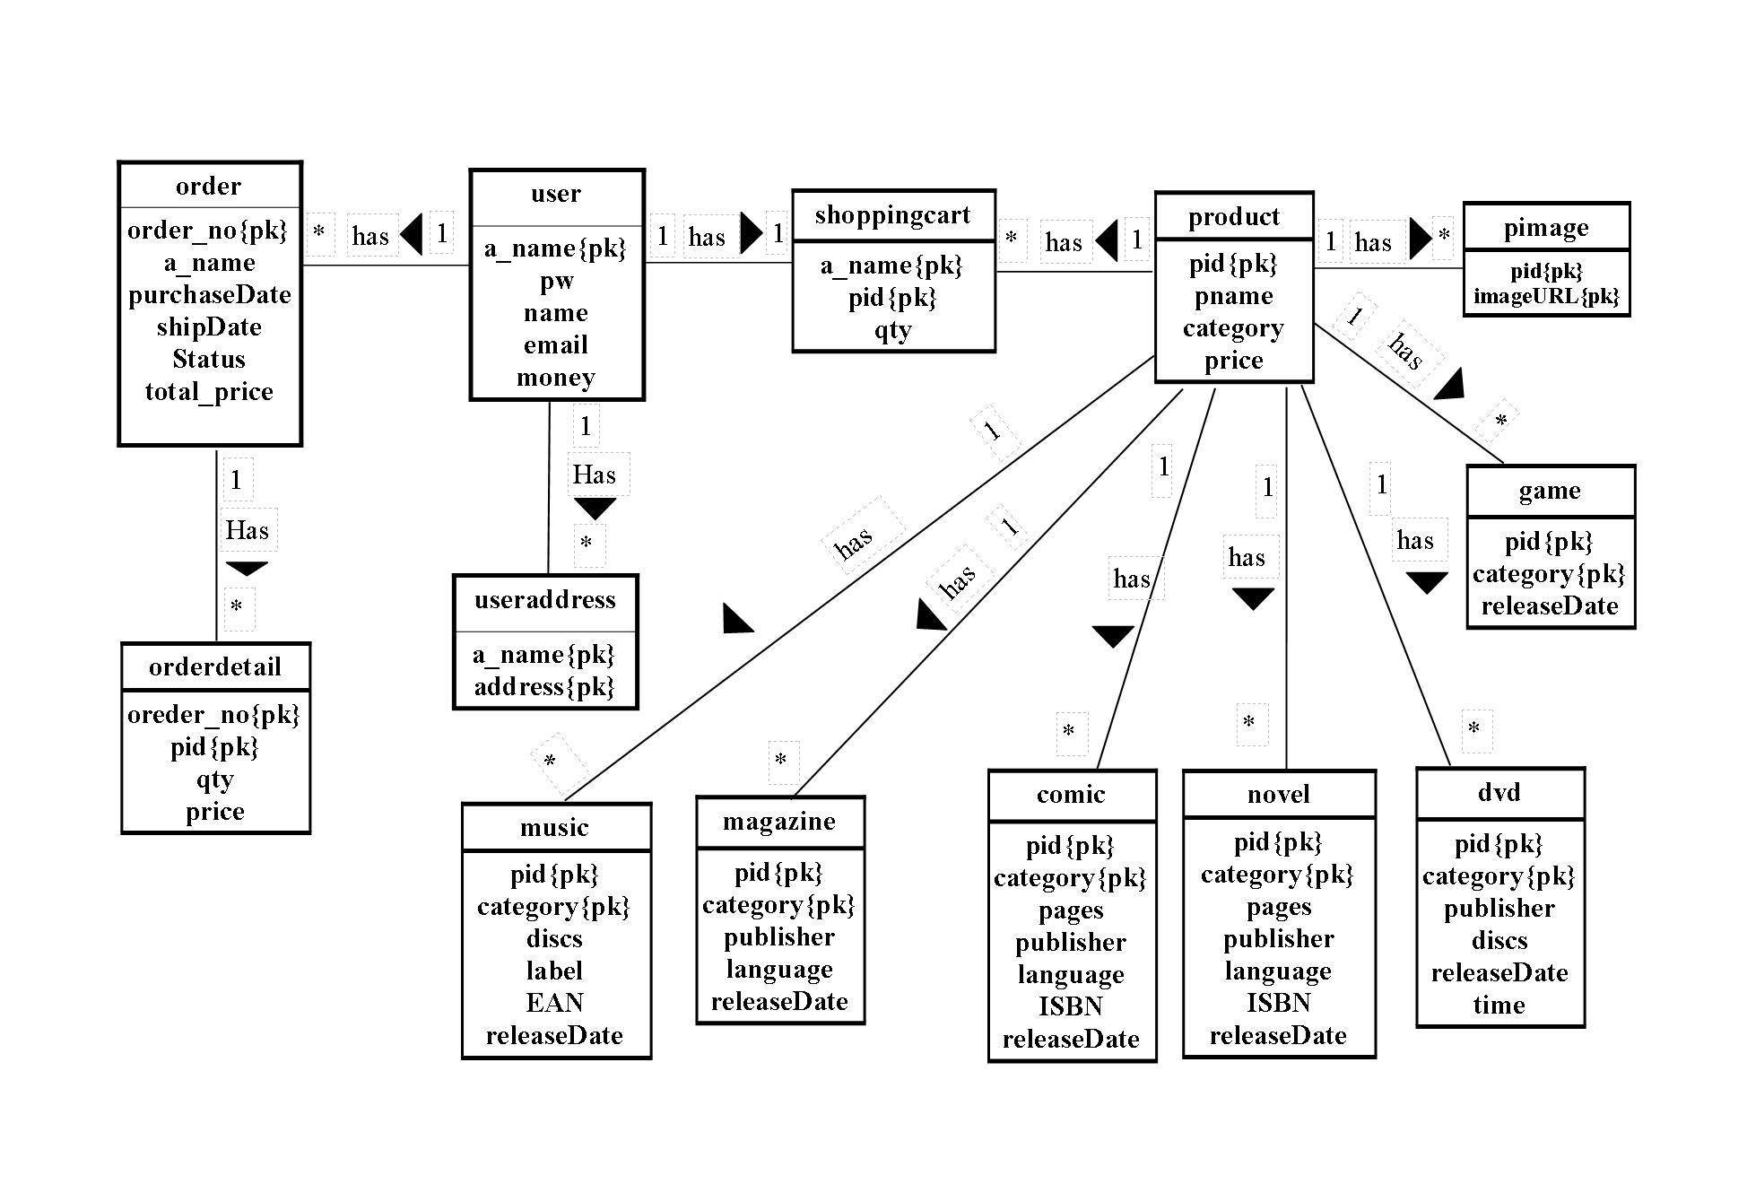

*Figure 3 ER diagram*

More description will be shown on the next page.

**user**

Each user has a unique account name (a\_name) to login system. And each user has one password (pw), one user name (name), one e-mail address (e-mail) for contact and money for buying products. Since user can have more than one shipping address (address), userAddress is separated into anther table to maintain a one-to-many relationship.

**user address**

As each user can have many shipping address for different orders, a\_name and address will be used as composite primary key.

**order**

Each user can order many times, so each user has more than one order. Order has a unique order number (order\_no) for tracking. Also, each order has one account name (a\_name) to record buyer. Each order has one purchase date (purchaseDate) for recording the date user buy the product, one shipping date (shipDate) for recording required date to ship, one order status (status) for the product status, including ‘pending’, ‘shipping’ and ‘hold’, and one total price (total\_price) showing the amount of money user should pay.

**orderDetail**

Each order has one or more products, so order has many order detail(orderDetail) that include order number(order\_no), product number(pid), quantity(qty) and price.

**product**

Each product has a unique product number(pid). Each product include category, product name(pname), price, quantity in stock (qty). Each user can rate product, we need sum up the rate of each user to be dividel by the total number of users who have rated.

**pimage**

Each product can have more than one image related to it. So, product image(image) is separated into pimage table. In this table pid and URL will be used as the composite primary key.

**shoppingcart**

Each user has one shopping cart. User can keep product he/she is interested in into shopping cart, which will record the product quantity as well.

**category**

For products’ detail information, as products in different categories will have different detail, there are 6 table containing different detail for different categories.

The data dictionary shown below serves as a catalog to give more detailed descriptions on the contents of the various tables in the database.

|  |  |  |  |  |  |  |  |
| --- | --- | --- | --- | --- | --- | --- | --- |
| **Entity** | **Attributes** | **Description** | **Data Type & Length** | | **Nulls** | **Multi-valued** | **domain** |
| **product** | pid | uniquely identifies a product | 8 | variable characters | No | No | 0 to 99999999 number |
| pname | product name | 30 | variable characters | No | No | 30 characters |
| category | product category | 8 | variable characters | No | No | music, magazine, comic, novel, dvd, game |
| price | product price | 8 | variable characters | No | No | 0 to 99999999 number |
| **pimage** | pid | uniquely identifies a product | 8 | variable characters | No | No | 0 to 99999999 number |
| imageURL | product's image URL | 200 | variable characters | No | No | 200 characters |
| **comic** | pid | uniquely identifies a product | 8 | variable characters | No | No | 0 to 99999999 number |
| category | identifies a product category | 12 | variable characters | No | No | music, magazine, comic, novel, DVD, game |
| pages | number of pages of the book | 4 | variable characters | Yes | No | 1 to 9999 number |
| publisher | the product publisher | 30 | variable characters | Yes | No | 30 characters |
| language | the product language | 12 | variable characters | Yes | No | 12 characters |
| ISBN | international standard book number | 13 | variable characters | Yes | No | 13 characters |
| releaseDate | the product release date |  | date | Yes | No | xxxx-xx-xx |
| **novel** | pid | uniquely identifies a product | 8 | variable characters | No | No | 0 to 99999999 number |
| category | identifies a product category | 12 | variable characters | No | No | music, magazine, comic, novel, DVD, game |
| pages | number of pages of the book | 4 | variable characters | Yes | No | 1 to 9999 number |
| publisher | the product publisher | 30 | variable characters | Yes | No | 30 characters |
| language | the product language | 12 | variable characters | Yes | No | 12 characters |
| ISBN | international standard book number | 13 | variable characters | Yes | No | 13 characters |
| releaseDate | the product release date |  | date | Yes | No | xxxx-xx-xx |
| **magazine** | pid | uniquely identifies a product | 8 | variable characters | No | No | 0 to 99999999 number |
| category | identifies a product category | 12 | variable characters | No | No | music, magazine, comic, novel, DVD, game |
| publisher | the product publisher | 30 | variable characters | Yes | No | 30 characters |
| language | the product language | 12 | variable characters | Yes | No | 12 characters |
| ISBN | international standard book number | 13 | variable characters | Yes | No | 13 characters |
| releaseDate | the product release date |  | date | Yes | No | xxxx-xx-xx |
| **music** | pid | uniquely identifies a product | 8 | variable characters | No | No | 0 to 99999999 number |
| category | identifies a product category | 12 | variable characters | No | No | music, magazine, comic, novel, DVD, game |
| discs | number of discs contains in the product | 4 | variable characters | Yes | No | 1 to 9 number |
| label | music label | 20 | variable characters | Yes | No | 20 characters |
| EAN | international article number | 13 | variable characters | Yes | No | 13 characters |
| releaseDate | the product release date |  | date | Yes | No | xxxx-xx-xx |
| **DVD** | pid | uniquely identifies a product | 8 | variable characters | No | No | 0 to 99999999 number |
| category | identifies a product category | 12 | variable characters | No | No | music, magazine, comic, novel, DVD, game |
| publisher | the product publisher | 30 | variable characters | Yes | No | 30 characters |
| discs | number of discs contains in the product | 4 | variable characters | Yes | No | 1 to 9 number |
| releaseDate | the product release date |  | date | Yes | No | xxxx-xx-xx |
| time | duration time  *Figure 4-1 Data Dictionary* |  | time | Yes | No | xx:xx:xx |

|  |  |  |  |  |  |  |  |
| --- | --- | --- | --- | --- | --- | --- | --- |
| **Entity** | **Attributes** | **Description** | **Data Type & Length** | | **Nulls** | **Multi-valued** | **domain** |
| **game** | pid | uniquely identifies a product | 8 | variable characters | No | No | 0 to 99999999 number |
| category | identifies a product category | 12 | variable characters | No | No | music, magazine, comic, novel, DVD, game |
| releaseDate | the product release date |  | date | No | No | xxxx-xx-xx |
| **user** | a\_name | uniquely identifies a user | 16 | variable characters | No | No | 6 to 16 character |
| pw | user's password that login system | 12 | variable characters | No | No | 8 to 12 character |
| name | user's name | 12 | variable characters | No | No | 3 to 12 character |
| email | user's e-mail | 30 | variable characters | No | No | 30 characters |
| money | user's money | 8 | variable characters | No | No | 1 to 99999999 number |
| **userAddress** | a\_name | uniquely identifies a user | 16 | variable characters | No | No | 6 to 16 character |
| address | user's shipping address | 30 | variable characters | No | No | 30 characters |
| **shoppingcart** | a\_name | uniquely identifies a user | 16 | variable characters | No | No | 6 to 16 character |
| pid | uniquely identifies a product | 8 | variable characters | No | No | 0 to 99999999 number |
| qty | user buy product quantity | 2 | variable characters | No | No | 1 to 99999999 number |
| **order** | order\_no | uniquely identifies a order | 8 | variable characters | No | No | 1 to 99999999 number |
| a\_name | uniquely identifies a user | 16 | variable characters | No | No | 6 to 16 character |
| purchaseDate | order purchase date |  | date | No | No | xxxx-xx-xx |
| shipDate | order shipping payment date |  | date | Yes | No | xxxx-xx-xx |
| status | Record the order status. | 10 | variable characters | No | No | pending, shipped, received |
| total\_price | products total price | 8 | variable characters | No | No | 1 to 99999999 number |
| **orderDetail** | order\_no | uniquely identifies a order | 8 | variable characters | No | No | 1 to 99999999 number |
| pid | uniquely identifies a product | 8 | variable characters | No | No | 0 to 99999999 number |
| qty | user buy product quantity | 2 | variable characters | No | No | 1 to 99999999 number |
| price | the product price  *Figure 4-2 Data Dictionary* | 8 | variable characters | No | No | 1 to 99999999 number |

## Dynamic Modeling

Shown below are state diagrams to represent the dynamics of the major process of our purchase process

Customer cart-in:

Customer login Rakuya Online Shop. And, customer view main page. Customer can search product, view shopping cart or click product image to view product detail. Customer can search key word in search bar and order by price. And then, product will list in product list page. Customer can click the product image or name to view product detail. Also, Customer can go to main page. Customer can cart-in product or increase product quantity to shopping cart in product detail page and go to shopping cart page. Customer can click product image or name to product detail page. Also, Customer can check out product. If customer’s account money is no enough, customer can’t checkout. Customer need remove some product from his list.

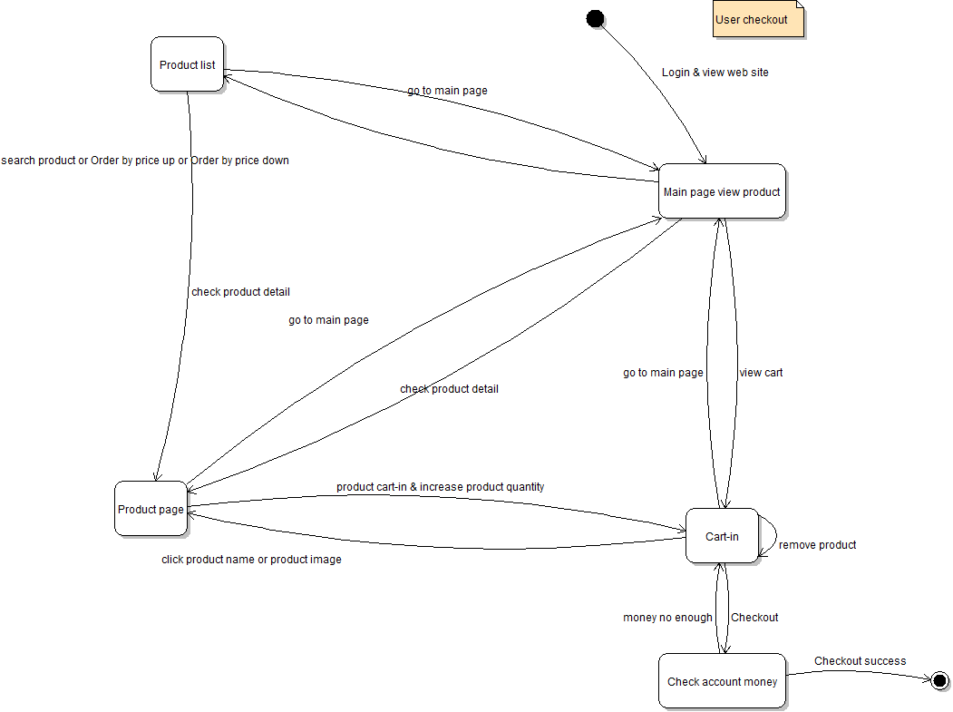

*Figure 5-1 State Diagram*

Customer confirm received:

Customer login Rakuya Online Shop. And customer can check order status in my page. As this moment, customer can search product and buy product in other order. When vendor shipped order, customer can see the shipping date in my page. Finally, customer receive product. Customer can in my page click confirm received to finish the order transaction.

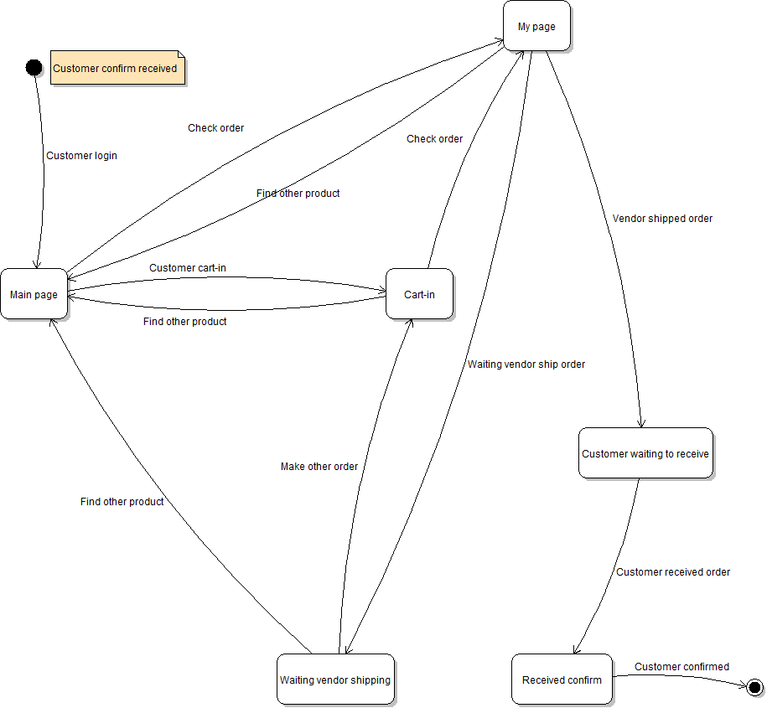

*Figure 5-2 State Diagram*

# System Implementation

## Platforms

To implement our online shopping rate, we use Dreamweaver CS6 [16] as the main development tool and Photoshop CS6 for image designing and editing. Our pages are mainly written in PHP, some of the functions are in JavaScript. Server we selected is Apache and our database is using MySQL in phpMyAdmin [17].

## Architecture

Our online-shopping mall is built using 3-layer architecture with browser as thin-client for presenting the user-interface to interact with our shopping mall, application server for processing the business logic and database for storing the data. The picture below summarizes this 3-layer architecture.

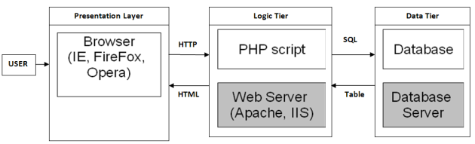

*Figure 6 Three-layer architecture* *[7]*

The presentation layer uses browser technology. For our project, the logic tier uses Apache as application server platform processing our PHP pages. The data tier is implemented using MySQL.

The user just needs a thin client and he/she may type something in the browser and then send to the web server through HTTP. The web server will process the application logic with data from database using SQL. After that, it will render the result in HTML and send to the browser to display.

## Module Design

Below are some major components of our online shopping mall.

1. Main Page: The user can choose a recommended product here or search a product using keywords.
2. Product List: It will display the result of product search based on the keywords of user input. Users can choose a product in product list.
3. Product Page: It will show detail information of a product and can put the product in a shopping cart.
4. Shopping Cart: The user can see all products which he/she has added to shopping cart. He/she can remove the product from cart list. Besides, the user can check out the cart items.
5. My Page: The user can see the information about himself/herself. Besides, he/she can see his/her order with status being “shipped”. When he/she receives the products, he/she can tell the vendor he/she had received the products by clicking the “confirmed”. In addition, he/she can change the password.
6. Insert: The vendor insert products with product detail in the database.
7. Order: The vendor can see the orders on different status namely pending, shipped and received. He/she can go to the order detail page as well.
8. Order Detail: The vendor can see the order detail which he/she has selected. Besides, he/she can ship a pending order.

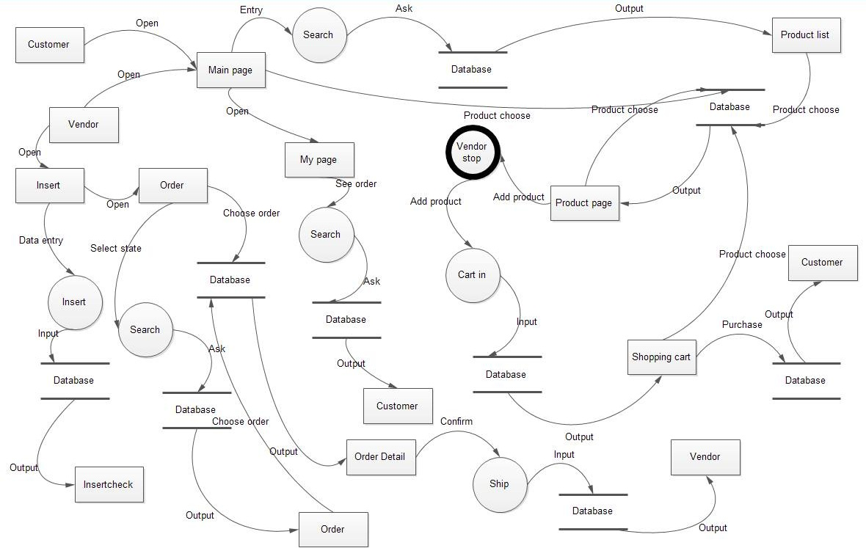

*Figure 7 Module Design*

# Results and Discussion

## Project Outcome

Shown below are some screen captures of the major, non-trivial functions of our shopping mall in order to show well we have implemented our system.

**Home Page**

We have a home page listing a lot of newest recommend products to user. User can click on a product to view more detailed information in product page.

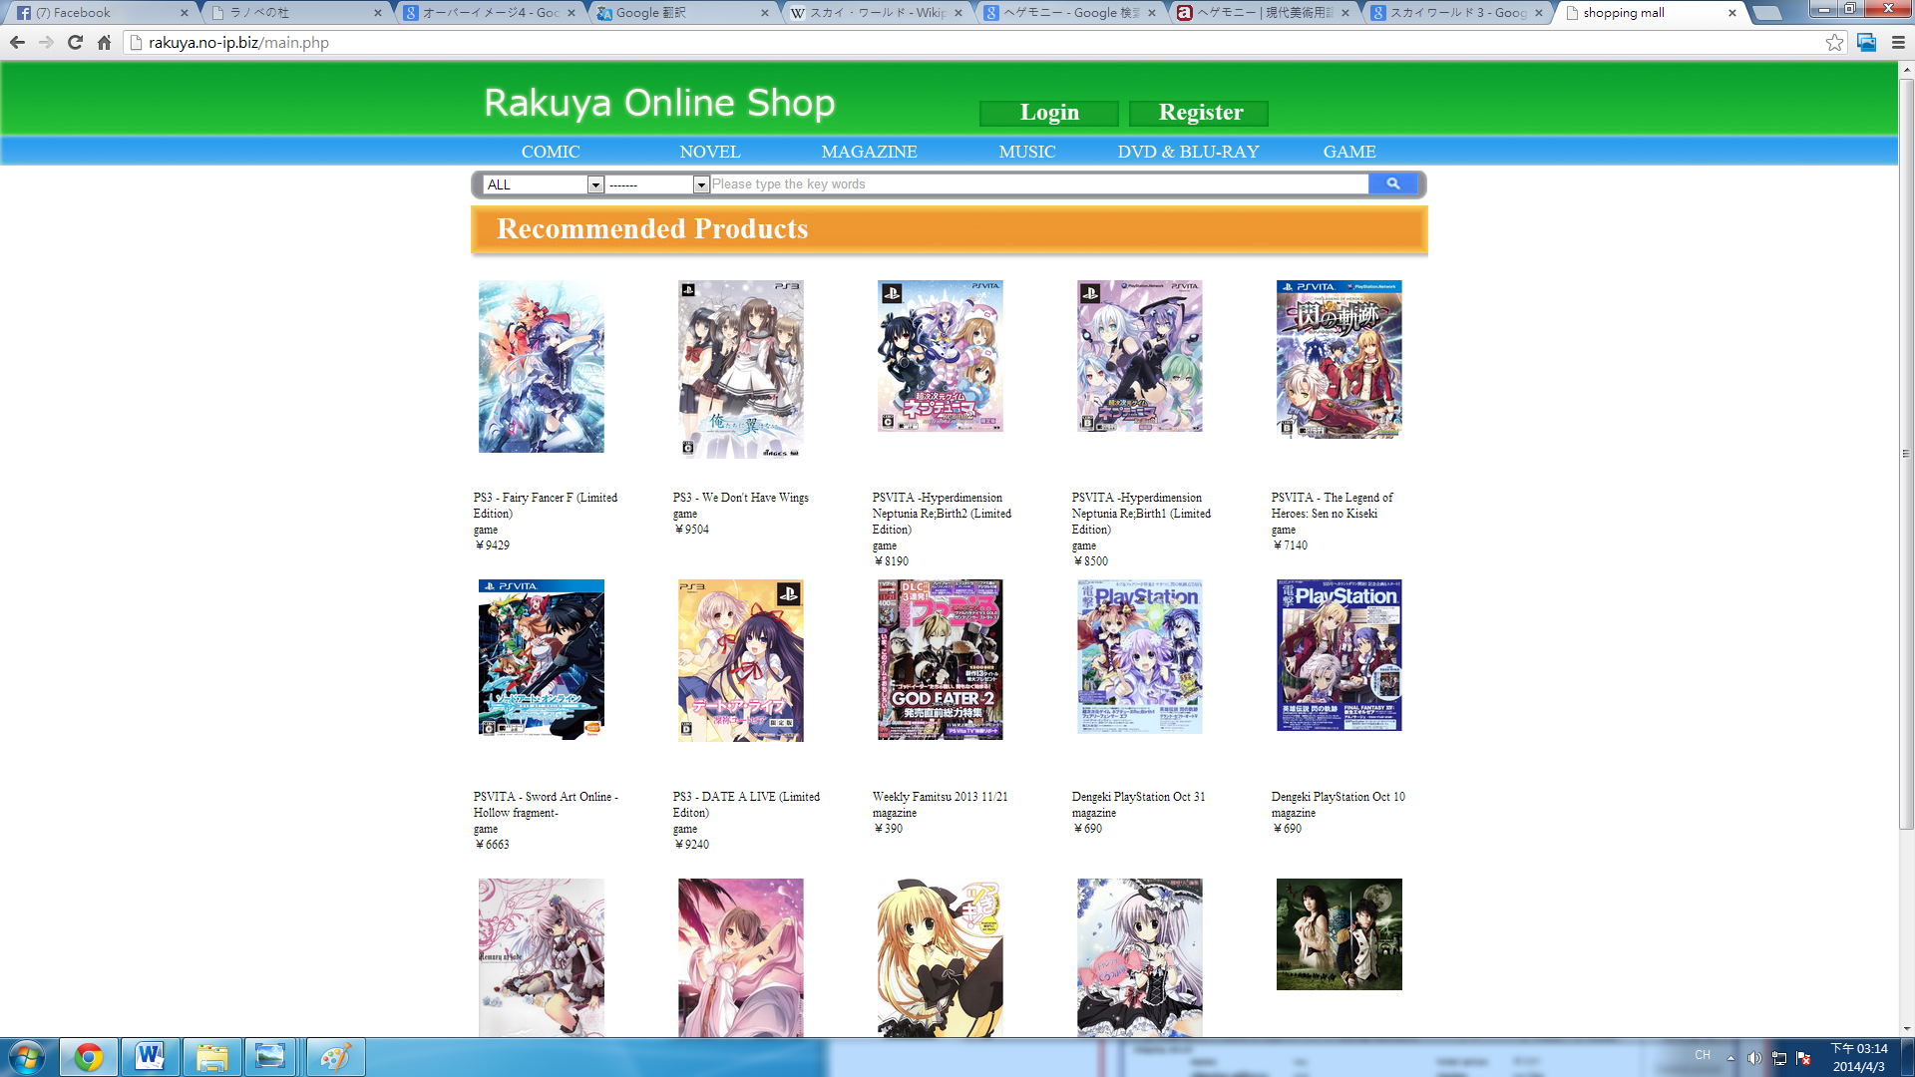

*Figure 8 Home Page*

User can do searching in this page by typing some key words into the search field. They can also select which category they want to search and select the order of the searching result.

**Product Page**



*Figure 1 Product Page*

In a product page, user can see all kinds of information for a product, such as the product name and category in square bracket, a thumbnail image, the release date, the price and detail description. In addition, user can select different images of this product to view. Also, he can add this product into his cart by clicking the ‘Cart in’ button. Selecting the quantity he/she wants to buy is also available. The default amount to add in cart is 1 and the maximum is 5 each time. The maximum is set to be 5 because it is rare that customers will buy in large quantity each time. However, he/she can add many times before he/she check out his/her cart if he really needs quantity more than 5.What’s more, we will recommend more products user may like in the same category.

**Shopping Cart**

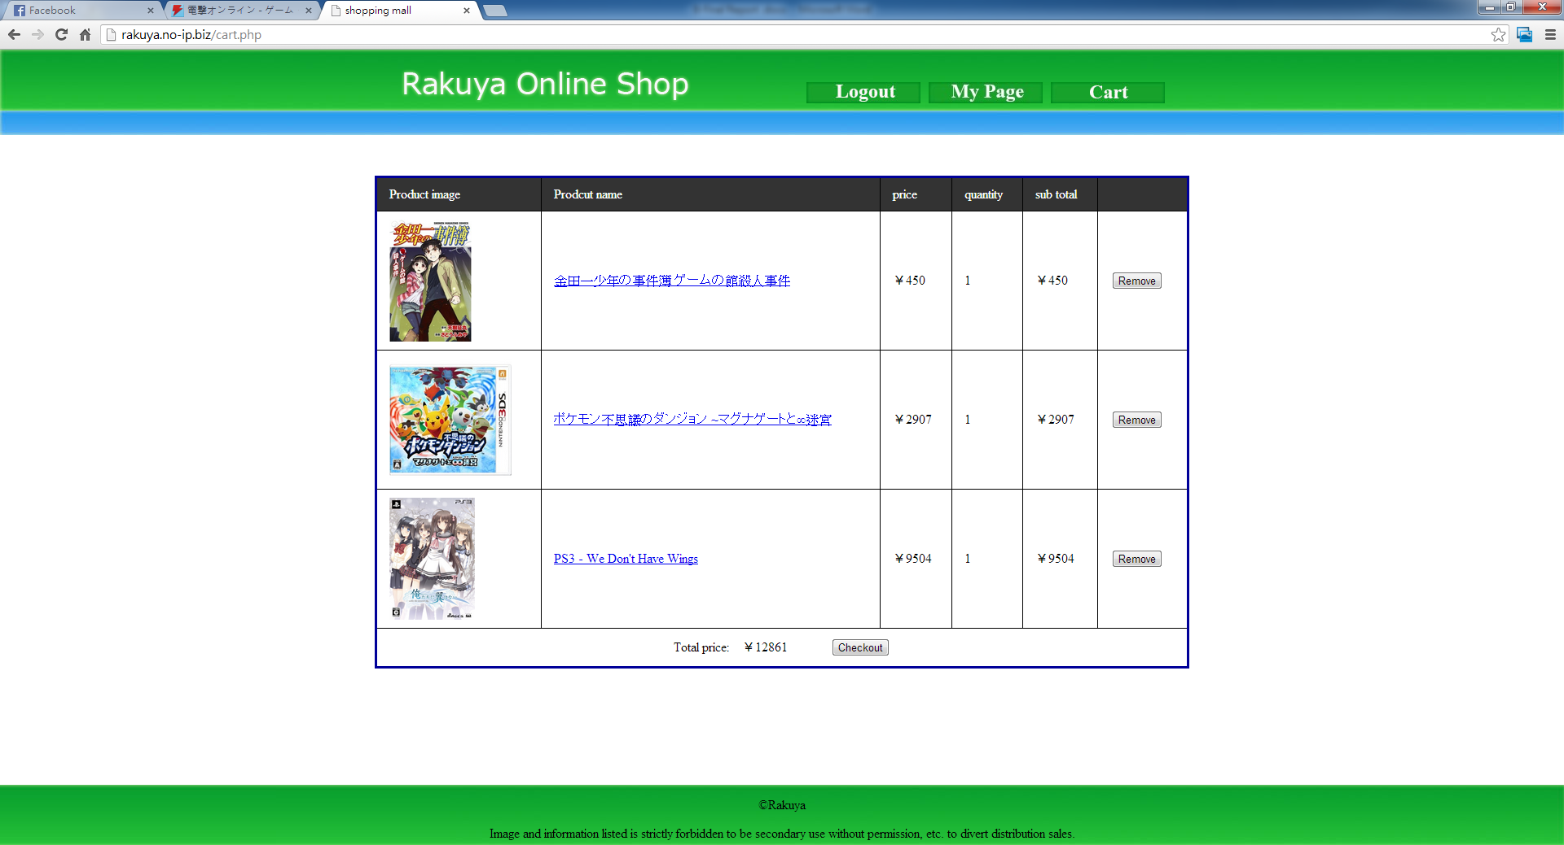

*Figure 9 Shopping Cart*

In shopping cart, user can see all the products that he/she adds to the cart but not yet check out. In each cart information will be shown as below: a thumbnail picture of the product, the name of the product, unit price of the product, the quantity of user adds into the cart, sub-total price of the product, and the total price of all the product user wants to order. Besides, for each product there is a "remove" button for user to remove a product from his/her cart if he/she does not want it.

**My Page**

**Change Password**



**User Personal   
Information**

*Figure 10-1 My Page*

**View All Orders**

**User Current   
Order List**

**Oldest**

**Latest**

In “my page”, he can see his/her personal information at the top. He/she can change password by clicking the ‘change password’ button on the right top corner. Under his/her profile, a list of current purchase orders, which are orders that have not been received, will be shown. For purchase order that have been shipped, he can change the status to “received” when the products arrive. The latest order will be shown on upper place. Also, user can press the ‘show all’ to see all of his/her order history including orders that have been confirmed on received. In all orders view, user can use ‘view current order’ button to go back to current order view.

****

*Figure 10-2 My Page*

**All User   
Purchase Order**

**Oldest**

**Latest**

**Vendor**

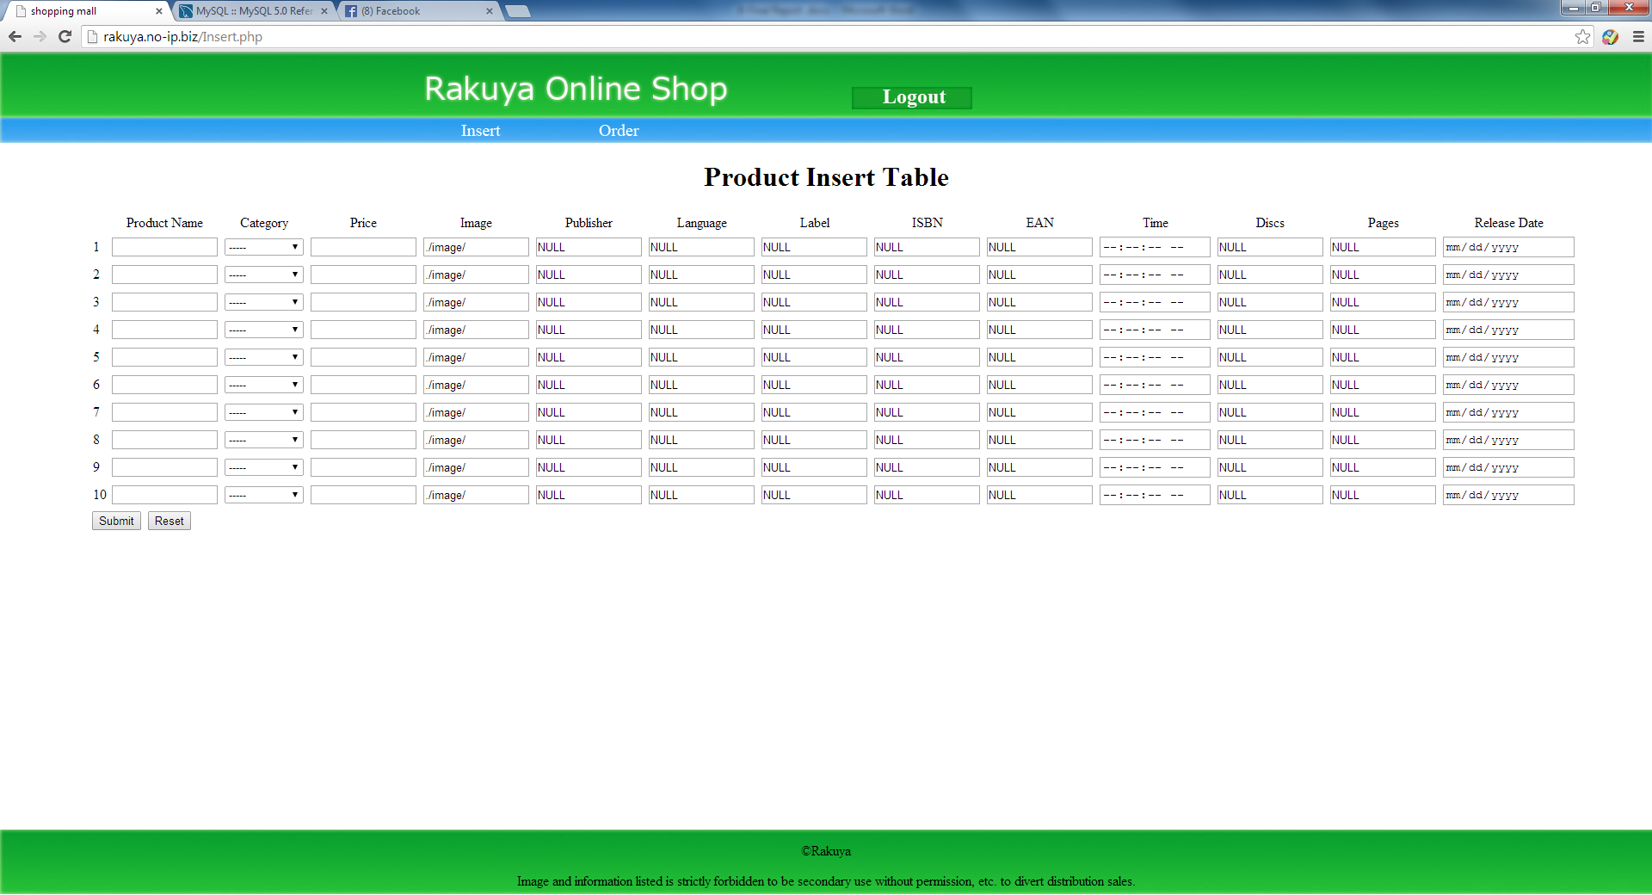

*Figure 11-1 Insert Page*

Once vendor login, he/she will go to this page and insert new products. Each time he can insert at most 10 products. Of course, vendor can go back to this page by pressing the "Insert" button in the blue bar at any time.

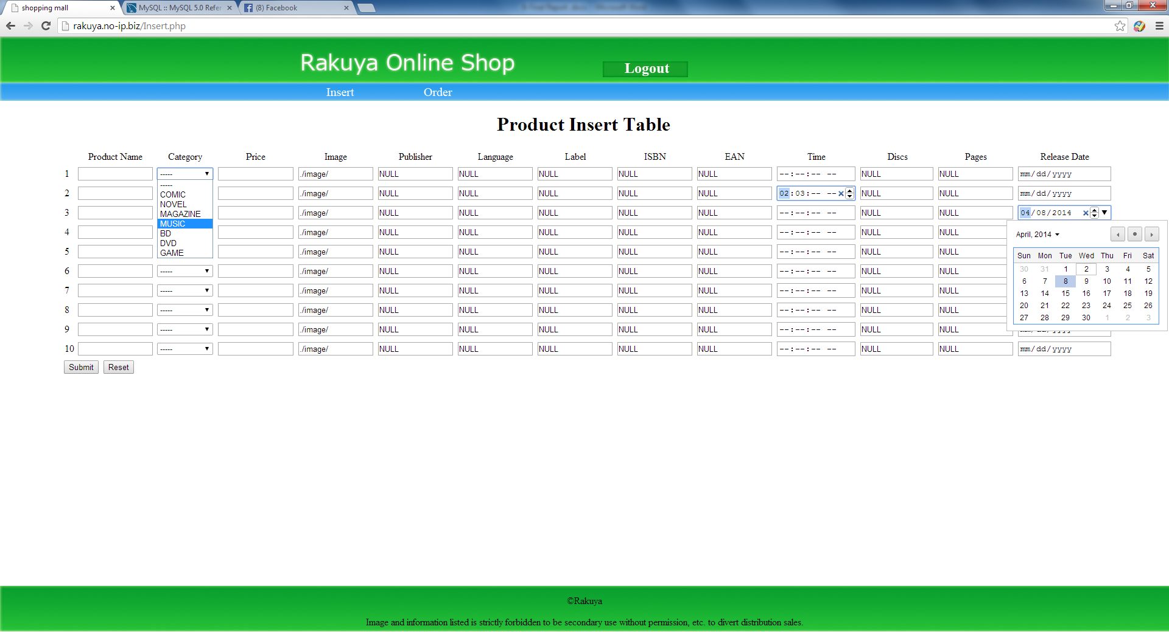

*Figure 11-2 Insert Page*

For each insertion, the first-four information is compulsory. For category vendor can do selection. And for image URL vendor just need to add the picture name before the default value ‘./image/’.

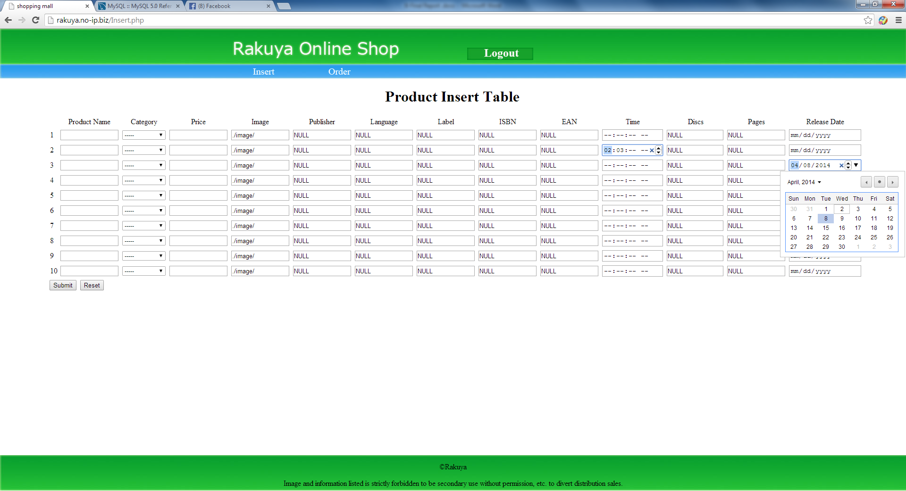

*Figure 11-3 Insert Page*

The remaining 9 information is optional if there is any. If there is no such information vendor can just leave the default value ‘NULL’. For special information such as time vendor can use up or down arrow to change value. Also, for date insertion, user can simply choose the date from the calendar.

**Check Orders**

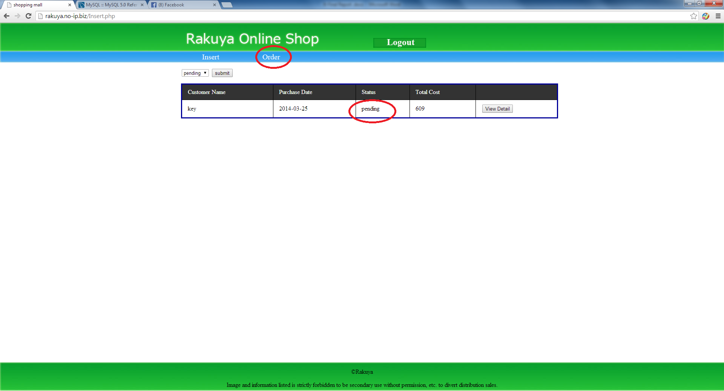

*Figure 12 Check Pending Orders*

Vendor can press the Order button to switch to another view to check orders from customers. In this page vendor can only see who makes the order, the date user purchase, the status of the order, and the total amount of the order. There is a “View Detail” button on the left to allow vendor to see more information about this order and ship the order once he/she starts delivery. This will be discussed later.

**Check Other Orders**

On the left top corner, there is a dropdown list to switch to other order lists such as shipped or received. However vendor cannot see detail of the order in “shipped” or “received” order pages.

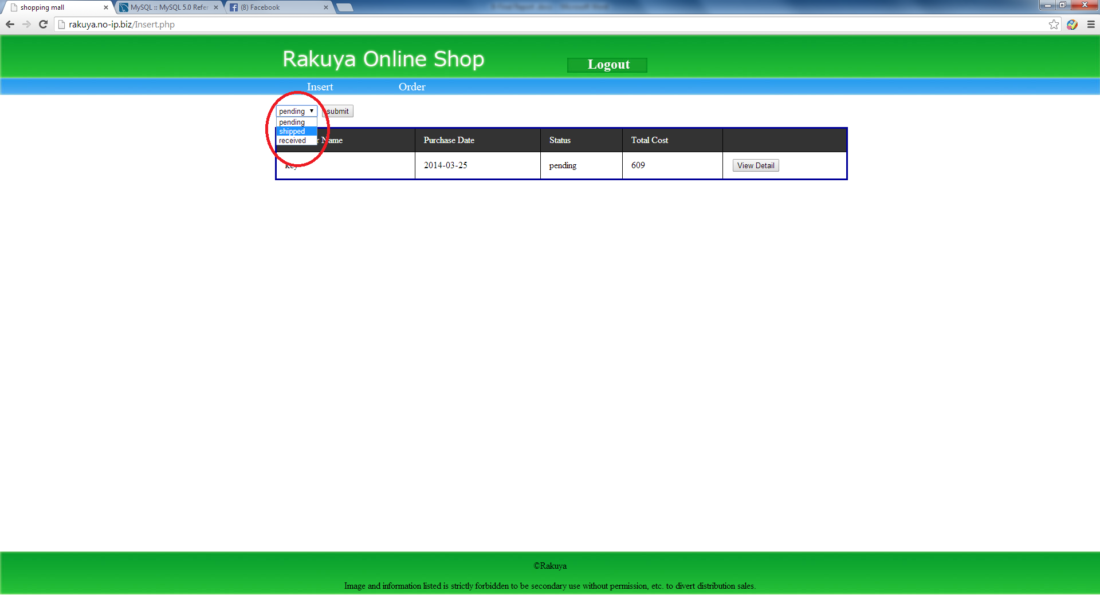

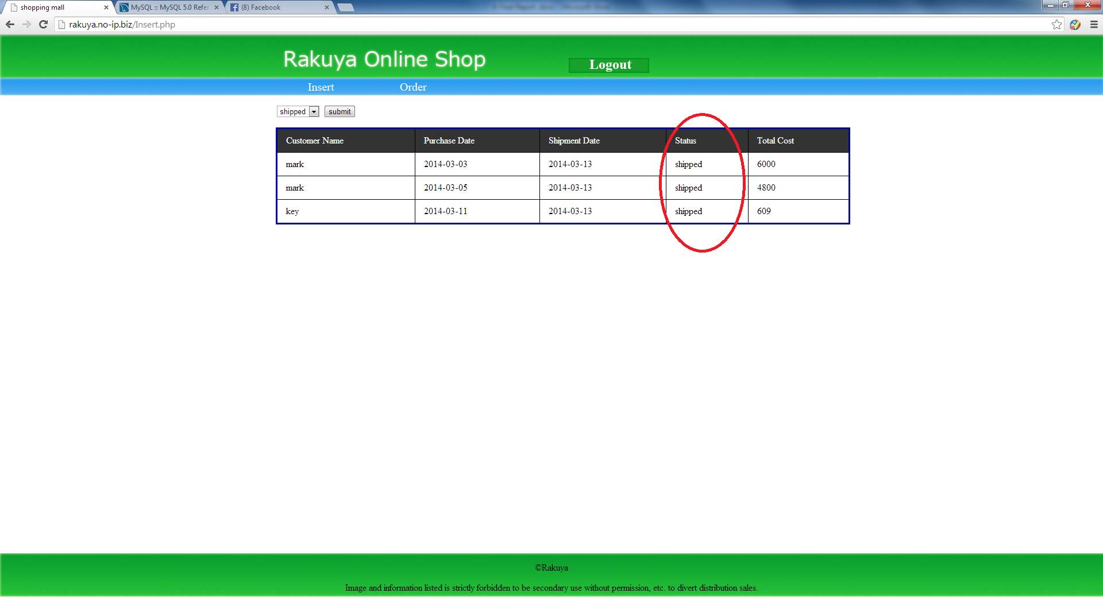

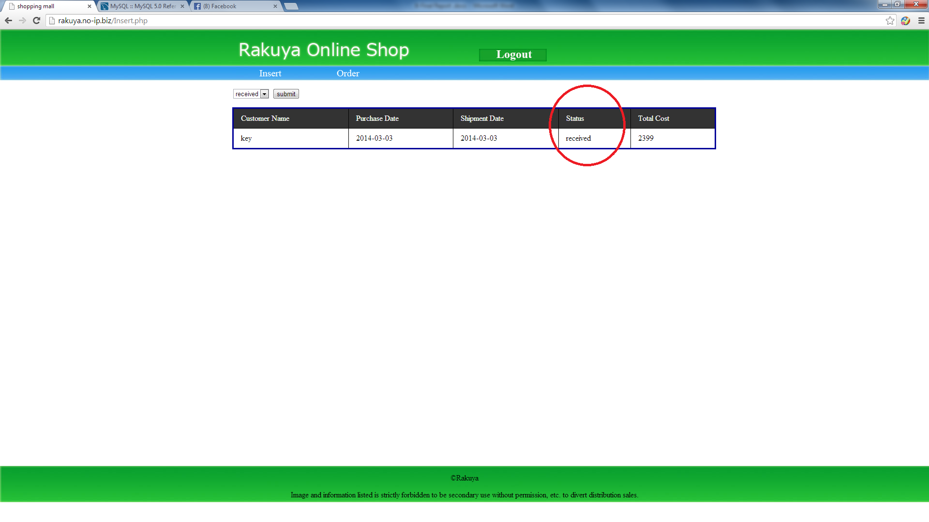

*Figure 13 Check Different Orders*

**Order Detail**

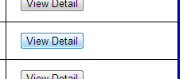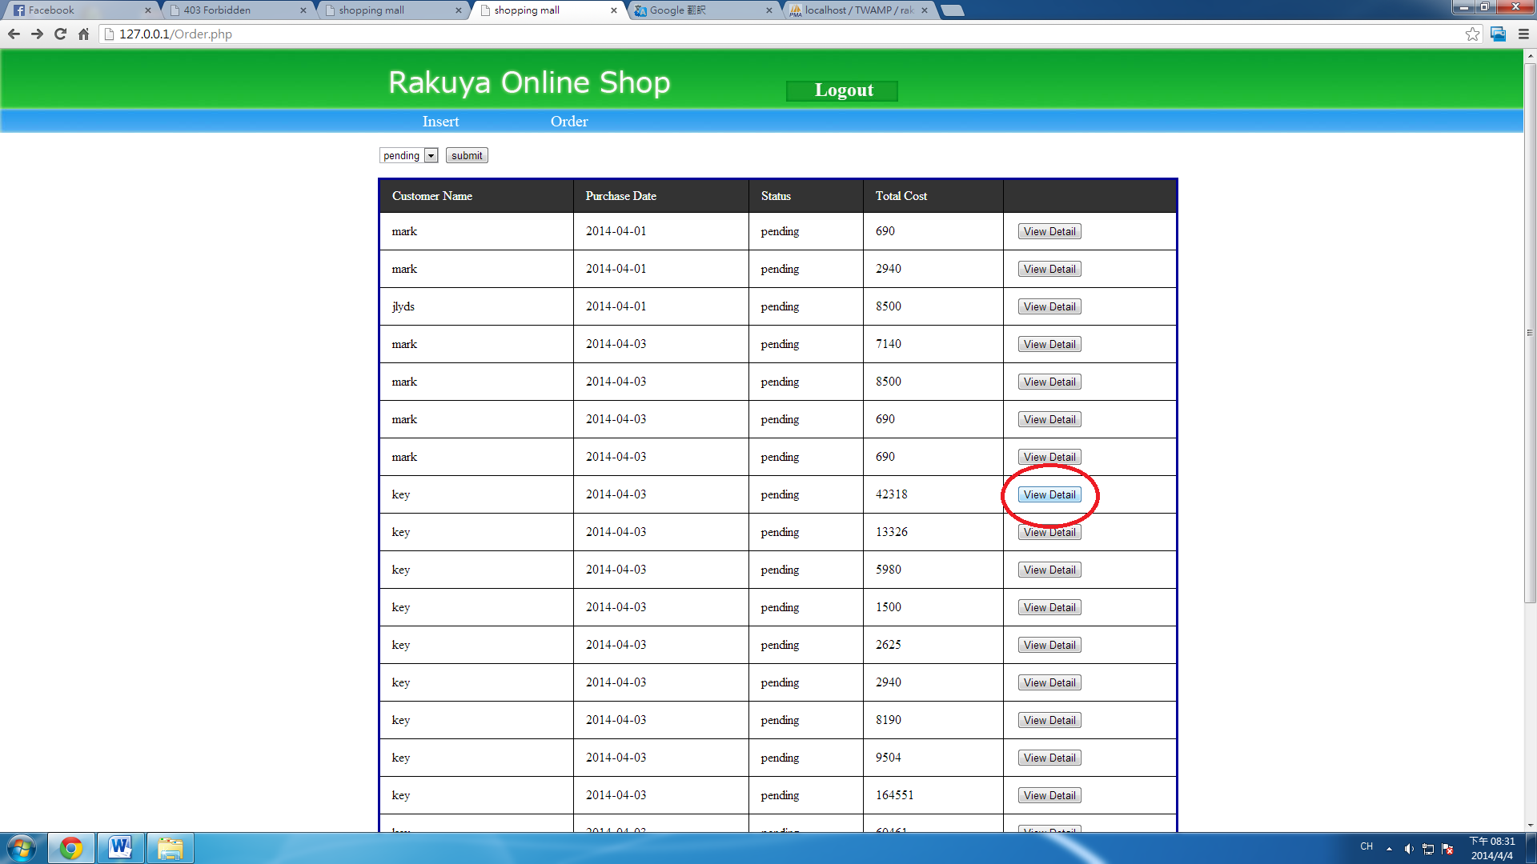

Press to view order detail and ship the order

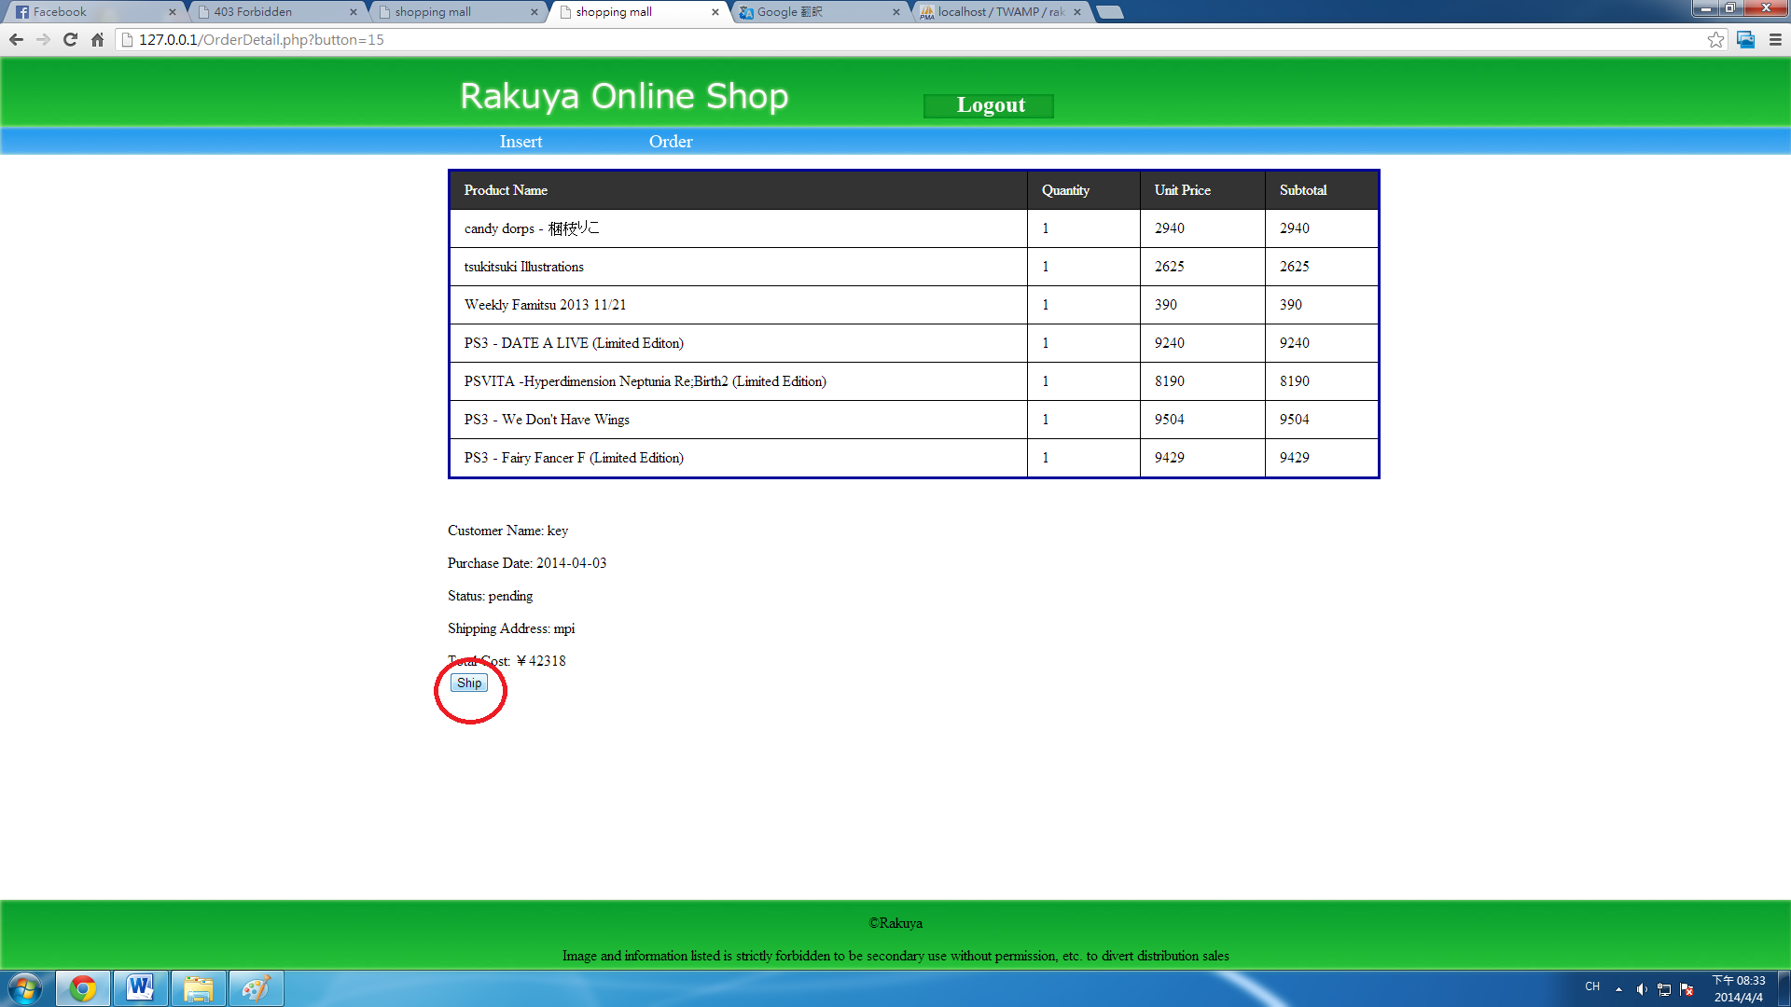

*Figure 14 View Order Detail*

A "view detail" button is available for each pending order as mentioned before. Once vendor press this button the page will change to view more detail of the order. Details of product name, quantity to buy, unit price and sub-total price will be list on the top. In addition, under the list of ordered products, customer name, purchase day, order status, shipping address as well as a total price of this order will be shown. What's more, under all the above information, a "ship" button is provided for vendor if the order is shipped to inform customer. If vendor wants to go back to order view other orders, he need to press the "Order" button in the blue bar.

## Testing

Shown below are the test cases designed to ensure that we have implemented the major, non-trivial functions with appropriate data validation and error checking.

|  |  |  |  |  |
| --- | --- | --- | --- | --- |
| Test Case #: 1 | | | | |
| Test Case Name: Change password | | | | |
| Module: My page | | | | |
| Short Description: Test input overflow data in change password page. | | | | |
| Pre-conditions | | | | |
| The user login chihou account. The user password is 'chihou'. The user view Mypage. | | | | |
| Step | Action | Expected System Response | Pass/Fail | comment |
| 1 | Click change password button | The system displays change password page | Pass |  |
| 2 | Click submit button | The system displays a message asking the user enter previous password | Pass |  |
| 3 | Enter previous password 'chihou' and Click submit button | The system displays a message asking the user enter change password | Pass |  |
| 4 | Enter change password 'mchihou' | The system displays a message asking the user enter change password | Pass |  |
| 5 | Enter change password 'mchihou123456789' | The system displays a message that prompt at most 12 character | Pass |  |
| 7 | Enter change password 'chihou123'  and Click submit button | The system displays a message asking the user enter confirm change password | Pass |  |
| 8 | Enter confirm change password 'chihou' and Click submit button | The system displays a message that prompt two password is not same | Pass |  |
| 9 | Enter confirm change password 'chihou123' and Click submit button | The system displays a message the user change password successThe system asks the user go to my page | Pass |  |
| 10 | Check post-condition 1 |  |  |  |
| Post-conditions | | | | |
| 1. The user password has been changed in the database.  *Figure 17 Test Case 1* | | | | |

|  |  |  |  |  |
| --- | --- | --- | --- | --- |
| Test Case #: 2 | | | | |
| Test Case Name: Cart-in overflow data | | | | |
| Module: Shopping Cart | | | | |
| Short Description: Test cart-in overflow quantity function. | | | | |
| Pre-conditions | | | | |
| The user login to system. The user has 97 products in shopping cart. | | | | |
| Step | Action | Expected System Response | Pass/Fail | comment |
| 1 | Choose 97 as quantity for a product and click the name or image in shopping cart. | The system displays product detail in product page. | Pass |  |
| 2 | Select 3 as quantity and click cart-in button | The system displays shopping cart with quantity as 99.  Note that there is a message on screen stating that the maximum can only be 99. | Pass |  |
| 3 | Check post-condition 1 |  |  |  |
| Post-conditions | | | | |
| 1. The product quantity has been changed in the database  *Figure 15 Test Case 2* | | | | |

|  |  |  |  |  |
| --- | --- | --- | --- | --- |
| Test Case #: 3 | | | | |
| Test Case Name: Cart-in checkout | | | | |
| Module: Shopping Cart | | | | |
| Short Description: Test not enough money to checkout. | | | | |
| Pre-conditions | | | | |
| The user login to system. The user has 2 products in shopping cart, one costs ¥4900, and the other costs ¥300. The user only has ¥5000 dollar. | | | | |
| Step | Action | Expected System Response | Pass/Fail | comment |
| 1 | Click checkout button | The system displays message 'Not enough money'. The system asks the user go to cart page. | Pass |  |
| 2 | Click cart page button | The system displays cart page. | Pass |  |
| 3 | Click remove button for ¥300-worth product from shopping cart. | The system displays remaining product on cart page. | Pass |  |
| 4 | Check post-condition 1 |  |  |  |
| 5 | Click checkout button | The system displays a message checkout success. The system displays asking the user go to my page. | Pass |  |
| 6 | Check post-condition 2 |  |  |  |
| 7 | Click my page button | The system displays my page. | Pass |  |
| Post-conditions | | | | |
| 1. The product removes from the database. 2. The new order is saved in the database.  All the products in shopping cart are removed from the database.  *Figure 16 Test Case 3* | | | | |

|  |  |  |  |  |  |  |  |
| --- | --- | --- | --- | --- | --- | --- | --- |
| Test Case #: 4 | | | | | | | |
| Test Case Name: register account overflow test | | | | | | | |
| Module: Register | | | | | | | |
| Short Description: Test Register function. | | | | | | | |
| Pre-conditions | | |  | |  | |  |
| The user view register page to register account. The user account does not exist. | | | | | | | |
| Step | Action | Expected System Response | | Pass/Fail | | comment | |
| 1 | Click submit button | The system displays a message that asking the user to enter full name | | Pass | |  | |
| 2 | Enter Full name 'Mak ChiHouchu'  and click submit button | The system displays a message that prompt at most 12 character string | | Pass | |  | |
| 3 | Enter Full name 'Mak ChiHou'  and click submit button | The system displays a message asking the user to enter account name | | Pass | |  | |
| 4 | Enter User account '12345678901234567' and click submit button | The system displays a message that prompt at most 16 character | | Pass | |  | |
| 5 | Enter User account 'chihou'  and click submit button | The system displays a message asking the user to enter user password | | Pass | |  | |
| 6 | Enter Password '1234567890123' and click submit button | The system displays a message that prompt at most 12 character | | Pass | |  | |
| 7 | Enter Password 'chihou' and click submit button | The system displays a message asking the user to enter confirm password | | Pass | |  | |
| 8 | Enter Confirm password '1234' and click submit button | The system displays a message that prompt two password is not same | | Pass | |  | |
| 9 | Enter Confirm password 'chihou' and click submit button | The system displays a message asking the user to enter Shipping address | | Pass | |  | |
| 10 | Enter Shipping address 'Macao Polytechnic Institute R. de Luis Gonzaga Gomes' | The system displays a message that prompt at most 30 character | | Pass | |  | |
| 11 | Enter Shipping address  'MPI R. de Luis Gonzaga Gomes' | The system displays a message asking the user to enter E-mail address | | Pass | |  | |
| 12 | Enter E-mail address 'chihou' and click submit button | The system displays a message the user to enter E-mail | | Pass | |  | |
| 13 | Enter Shipping address '1234567890123456789012345@ipm.edu.mo' | The system displays a message that prompt at most 30 character | | Pass | |  | |
| 14 | Enter E-mail address 'chihou@ipm.edu.mo' and click submit button | The system displays a message the user register success The system displays a message asks the user go to main page | | Pass | |  | |
| 15 | Check post-condition 1 |  | |  | |  | |
| Post-conditions | |  | |  | |  | |
| 1. The new account name 'chihou' is saved in the database.  The new account password 'chihou' is saved in the database.  The new full name 'Mak ChiHou' is saved in the database.  The new shipping address 'MPI R. de Luis Gonzaga Gomes' is saved in the database.  The new e-mail address 'chihou@ipm.edu.mo' is saved in the database.  *Figure 18 Test Case 4* | | | | | | | |

|  |  |  |  |  |  |  |  |
| --- | --- | --- | --- | --- | --- | --- | --- |
| Test Case #: 4 | | | | | | | |
| Test Case Name: register account overflow test | | | | | | | |
| Module: Register | | | | | | | |
| Short Description: Test Register function. | | | | | | | |
| Pre-conditions | | |  | |  | |  |
| The user view register page to register account. The user account does not exist. | | | | | | | |
| Step | Action | Expected System Response | | Pass/Fail | | comment | |
| 1 | Click submit button | The system displays a message that asking the user to enter full name | | Pass | |  | |
| 2 | Enter Full name 'Mak ChiHouchu'  and click submit button | The system displays a message that prompt at most 12 character string | | Pass | |  | |
| 3 | Enter Full name 'Mak ChiHou'  and click submit button | The system displays a message asking the user to enter account name | | Pass | |  | |
| 4 | Enter User account '12345678901234567' and click submit button | The system displays a message that prompt at most 16 character | | Pass | |  | |
| 5 | Enter User account 'chihou'  and click submit button | The system displays a message asking the user to enter user password | | Pass | |  | |
| 6 | Enter Password '1234567890123' and click submit button | The system displays a message that prompt at most 12 character | | Pass | |  | |
| 7 | Enter Password 'chihou' and click submit button | The system displays a message asking the user to enter confirm password | | Pass | |  | |
| 8 | Enter Confirm password '1234' and click submit button | The system displays a message that prompt two password is not same | | Pass | |  | |
| 9 | Enter Confirm password 'chihou' and click submit button | The system displays a message asking the user to enter Shipping address | | Pass | |  | |
| 10 | Enter Shipping address 'Macao Polytechnic Institute R. de Luis Gonzaga Gomes' | The system displays a message that prompt at most 30 character | | Pass | |  | |
| 11 | Enter Shipping address  'MPI R. de Luis Gonzaga Gomes' | The system displays a message asking the user to enter E-mail address | | Pass | |  | |
| 12 | Enter E-mail address 'chihou' and click submit button | The system displays a message the user to enter E-mail | | Pass | |  | |
| 13 | Enter Shipping address '1234567890123456789012345@ipm.edu.mo' | The system displays a message that prompt at most 30 character | | Pass | |  | |
| 14 | Enter E-mail address 'chihou@ipm.edu.mo' and click submit button | The system displays a message the user register success The system displays a message asks the user go to main page | | Pass | |  | |
| 15 | Check post-condition 1 |  | |  | |  | |
| Post-conditions | |  | |  | |  | |
| 1. The new account name 'chihou' is saved in the database.  The new account password 'chihou' is saved in the database.  The new full name 'Mak ChiHou' is saved in the database.  The new shipping address 'MPI R. de Luis Gonzaga Gomes' is saved in the database.  The new e-mail address 'chihou@ipm.edu.mo' is saved in the database.  *Figure 18 Test Case 4* | | | | | | | |

|  |  |  |  |  |  |  |  |
| --- | --- | --- | --- | --- | --- | --- | --- |
| Test Case #: 5 | | | | | | | |
| Test Case Name: Insert product | | | | | | | |
| Module: Insert | | | | | | | |
| Short Description: Test insert product function | | | | | | | |
| Pre-conditions | | |  | |  | |  |
| The vendor has login to system. The user view Insert page. | | | | | | | |
| Step | Action | Expected System Response | | Pass/Fail | | comment | |
| 1 | Enter product name 'Pokemon' | The system displays a message asking the user to choose category | | Pass | |  | |
| 2 | Choose category 'COMIC' | The system displays a message asking the user to enter price | | Pass | |  | |
| 3 | Enter price'1500' | The system displays a message asking the user to enter image URL | | Pass | |  | |
| 4 | Enter image 'http://img4.wikia.nocookie.net/\_\_cb20081230114050/pokemon/zh-hk/images/9/9c/%E6%AF%94%E5%8D%A1%E8%B6%85.gif' | The system displays a message asking the user to enter publisher | | Pass | |  | |
| 5 | Enter publisher 'Pokemon company' | The system displays a message asking the user to enter Language | | Pass | |  | |
| 6 | Enter language 'Japanese' | The system displays a message asking the user to enter ISBN | | Pass | |  | |
| 7 | Enter ISBN '9702043817821' | The system displays a message asking the user to enter Pages | | Pass | |  | |
| 8 | Enter pages '200' | The system displays a message asking the user to enter Release date | | Pass | |  | |
| 9 | Enter release date '1997-12-17' | The system displays a message the user success add the product  The system displays a message asking the user to go insert page | | Pass | |  | |
| 10 | Check post-condition 1 |  | |  | |  | |
| Post-conditions | |  | |  | |  | |
| 1. The product name 'Pokemon' is saved in the database.  The product category 'COMIC' is saved in the database.   The product price '1500' is saved in the database.  The product imageURL 'http://img4.wikia.nocookie.net/\_\_cb20081230114050/pokemon/zh-hk/images/9/9c/%E6%AF%94%E5%8D%A1%E8%B6%85.gif'' is saved in the database. .  The product publisher 'Pokemon company' is saved in the database.  The product language 'Japanese' is saved in the database.  The product ISBN '9702043817821' is saved in the database.  The product pages '200' is saved in the database.  The product release date '1997-12-17' is saved in the database.  *Figure 18 Test Case 5* | | | | | | | |

|  |  |  |  |  |
| --- | --- | --- | --- | --- |
| Test Case #: 6 | | | | |
| Test Case Name: Vendor Status change | | | | |
| Module: OrderList | | | | |
| Short Description: Test vendor change order status | | | | |
| Pre-conditions | | | | |
| The vendor has login to his account. The user view order list. | | | | |
| Step | Action | Expected System Response | Pass/Fail | comment |
| 1 | Choose pending and Click submit button | The system displays pending orders | Pass |  |
| 2 | Click View Detail | The system displays the order detail | Pass |  |
| 3 | click Ship button | The system displays message the order status had been changed  The system asks the user if he wants to perform other operations | Pass |  |
| 4 | Check post-condition 1 |  |  |  |
| 5 | Choose shipped and Click submit button | The system displays orders is pending | Pass |  |
| 6 | Choose received and Click submit button | The system displays orders is received | Pass |  |
| Post-conditions | | | | |
| 1. The order status 'pending' change to 'shipping' in the database.  The order shipment date 'Null' change to the system date in the database.  *Figure 18 Test Case 6* | | | | |

|  |  |  |  |  |
| --- | --- | --- | --- | --- |
| Test Case #: 7 | | | | |
| Test Case Name: Buyer order status change | | | | |
| Module: My page | | | | |
| Short Description: Test buyer order change order status | | | | |
| Pre-conditions | | | | |
| The buyer login account. The buyer view main page. The buyer has 3 orders. First order's status is pending. Second order's status is shipped. Third orders' status is received. | | | | |
| Step | Action | Expected System Response | Pass/Fail | comment |
| 1 | Click my page button | The system displays current order that belong to the buyer  The system displays the buyer information  The system displays order detail include product name, quantity, price, sub-total, purchase date, total price, status, shipping address, shipment date and buyer name. | Pass |  |
| 2 | Click view all button | The system displays all order that belong to the buyer  The system displays the buyer information  The system displays order detail include product name, quantity, price, sub-total, purchase date, total price, status, shipping address, shipment date and buyer name.  if order's status is 'shipped', the system displays confirm received button | Pass |  |
| 3 | Click confirm received button | The system displays a message the buyer confirm success | Pass |  |
| 4 | Check post-condition 1 |  |  |  |
| Post-conditions | | | | |
| 1. The order status 'shipped' change to 'received' in the database.  *Figure 19 Test Case 7* | | | | |

|  |  |  |  |  |
| --- | --- | --- | --- | --- |
| Test Case #: 8 | | | | |
| Test Case Name: Search product | | | | |
| Module: Main page | | | | |
| Short Description: Test search relative product | | | | |
| Pre-conditions | | | | |
| The user view main page. | | | | |
| Step | Action | Expected System Response | Pass/Fail | comment |
| 1 | Enter 'poke' in search bar | The system displays about 'poke' relative product  If database hasn't relative product, the system displays no search result | Pass |  |
| 2 | Click Rakuya Online Shop logo | The system displays main page | Pass |  |
| 3 | Click search logo | If Search result more than 5, the system displays 5 product that order by product ID  If Search result more than 5, the system displays next button  If Search result less than 5, the system displays all product | Pass |  |
| 4 | Click next button | If Search result more than 5, the system displays other 5 product that order by product ID  The system displays previous button If Search result more than 10, the system displays next button | Pass |  |
| 5 | Click previous button | The system displays 5 product that order by product ID | Pass |  |
| 6 | Click search logo | The system displays 5 product that order by product ID | Pass |  |
| 7 | Choose novel and price up and Click search logo | If Search result more than 5, the system displays 5 product of novel that order by cheapness  If Search result more than 5, the system displays next button | Pass |  |
| 8 | Click Rakuya Online Shop logo | The system displays main page | Pass |  |
| 9 | Choose magazine and price down and Click search logo | If Search result more than 5, the system displays 5 product of magazine that order by costliness  If Search result more than 5, the system displays next button | Pass |  |
| 10 | Click Rakuya Online Shop logo | The system displays main page | Pass |  |
| 11 | Choose Music and Click search logo | If Search result more than 5, the system displays 5 product of music that order by product ID  If Search result more than 5, the system displays next button | Pass |  |
| 12 | Click Rakuya Online Shop logo | The system displays main page | Pass |  |
| 13 | Choose DVD&BLU-RAY and Enter 'pokemon' | If Search result more than 5,The system displays 5 product of DVD or BLU-RAY that order by product ID  If Search result more than 5, the system displays next button | Pass |  |
| 14 | Click Rakuya Online Shop logo | The system displays main page | Pass |  |
| 15 | Choose game and price down Enter 'pokemon'  *Figure 20 Test Case 8* | If Search result more than 5,The system displays 5 'pokemon' relative product of game that order by costliness  If Search result more than 5, the system displays next button | Pass |  |

# Conclusion and Further Work

In conclusion, all our works are done according to the schedule. In our project, we have finished 32 functions including 22 for customer and 8 for vendor as listed in section 1.2. The outcome of our website has a user-friendly interface. Customer who wants to buy products from our website can easily use it. Besides, we provide easy-to-use interface for vendor to insert new goods. It is convenient for all users to use our website in anytime and at anywhere.

As this is a project done for our information system implementation course, we limit the scope of some functions. Since we are 3 people group, we just finish 32 requirements out of 53. Other limitations are we do not allow user input money. Therefore, user has no way to increase money in his/her account except he/she contacts the vendor and do changes in database directly. And we do not have a connection with any extra payment system. All the user money is simply written in our database. Besides, we do not have any protection setting for our website. If some virus attacks our website it may cause system crash. Also, our database is accessible through the Internet. If others know our database information, he/she can change data inside. What’s more, as we are using some free source technology, such as the DNS we are using is provided by No-IP Free Dynamic DNS [17], sometimes user may fail to access our website.

In addition, we are still planning to do some improvement for our website. For example, we can add some functions allowing user to add some new shipping address and user can choose where they want to ship. This is already prepared in our database design, as we create a new table called ‘useraddress’ putting user address in it. Moreover, since the our design we need vendor to put new product pictures into server when he/she is using the computer running server, we can develop a new function to let him/her upload picture at any place. Furthermore, we can setup a ranking function for user to rank a product after he/she login. And searching product in ranking order will then be also available. Also, more order status can be set to each order. For instance, allowing user to cancel order that is not yet shipped and allow vendor to hold the orders if he/she cannot ship the order in a few days. Last but not least, we can add a function to allow user to give comments to each products.

# References

[1] Amazon. A short guide for writing a thesis. http://www.amazon.co.jp/. [April 2014].

[2] Amazon. A short guide for writing a thesis. http://www.amazon.co.jp/s/ref=sr\_nr\_p\_n\_binding\_browse-b\_mrr\_1?rh=n%3A465392%2Cp\_n\_binding\_browse-bin%3A86139051&bbn=465392&ie=UTF8&qid=1396944371&rnid=625256011. [April 2014].

[3] Amazon. A short guide for writing a thesis. http://www.amazon.co.jp/gp/feature.html/ref=cocacola140407?ie=UTF8&docId=3077988316. [April 2014].

[4] Amazon. A short guide for writing a thesis. http://www.amazon.co.jp/gp/cart/view.html/ref=gno\_cart. [April 2014].

[5] Amazon. A short guide for writing a thesis. https://www.amazon.co.jp/ap/signin?\_encoding=UTF8&openid.assoc\_handle=jpflex&openid.claimed\_id=http%3A%2F%2Fspecs.openid.net%2Fauth%2F2.0%2Fidentifier\_select&openid.identity=http%3A%2F%2Fspecs.openid.net%2Fauth%2F2.0%2Fidentifier\_select&openid.mode=checkid\_setup&openid.ns=http%3A%2F%2Fspecs.openid.net%2Fauth%2F2.0&openid.ns.pape=http%3A%2F%2Fspecs.openid.net%2Fextensions%2Fpape%2F1.0&openid.pape.max\_auth\_age=0&openid.return\_to=https%3A%2F%2Fwww.amazon.co.jp%2Fgp%2Fyourstore%2Fhome%3Fie%3DUTF8%26ref\_%3Dgno\_signin. [April 2014].

[6] Amazon. A short guide for writing a thesis. https://www.amazon.co.jp/gp/css/homepage.html/ref=topnav\_ya. [April 2014].

[7] Ali Tarhini. Concepts of Three-Tier Architecture. http://alitarhini.wordpress.com/2011/01/22/concepts-of-three-tier-architecture/. [April 2014].

[8] cefour. 6 3 tier architecture php. http://www.slideshare.net/cefour/6-3-tier-architecture-php. [April 2014].

[9] Dr Ghazy Assassa. Test Case Template and Examples. http://faculty.ksu.edu.sa/ghazy/CSC342\_Tools/Test%20Case%20Template.pdf. [April 2014].

[10] w3schools. PHP 5 Tutorial. http://www.w3schools.com/PHP/. [February 2014].

[11] Fujimishobo. http://www.fujimishobo.co.jp/top.php. [February 2014].

[12] KADOKAWA. https://wwws.kadokawa.co.jp/shop/cart.php?-add=201302000005. [February 2014].

[13] Gamers Onlineshop. http://www.gamers-onlineshop.jp/products/list.php?mode=search&smt=&submit.x=4&submit.y=11. [February 2014].

[14] Gamers Onlineshop. http://www.gamers-onlineshop.jp/pn/%E3%80%90%E5%B0%8F%E8%AA%AC%E3%80%91%E9%8A%83%E7%9A%87%E7%84%A1%E5%B0%BD%E3%81%AE%E3%83%95%E3%82%A1%E3%83%95%E3%83%8B%E3%83%BC%E3%83%AB%284%29+%E3%82%B9%E3%83%94%E3%83%AA%E3%83%83%E3%83%88%E3%83%BB%E3%83%8F%E3%82%A6%E3%83%AA%E3%83%B3%E3%82%B0/pd/10156863/. [February 2014].

[15] Adobe Dreamwaver CS6. Dreamweaver Help/CS6 Help and tutorials http://helpx.adobe.com/dreamweaver/topics-cs6.html. [February 2014].

[16] phpMyAdmin. Bring MySQL to the web. http://www.phpmyadmin.net/. [February 2014].

[17] No-IP Free Dynamic DNS. http://freedns.no-ip.com/. [March 2014].

[18] Chan Wai Ching, Chan Jun rong. PHP5&MySQL program design 2 edition. [February 2014].

# Appendix

## Project plan

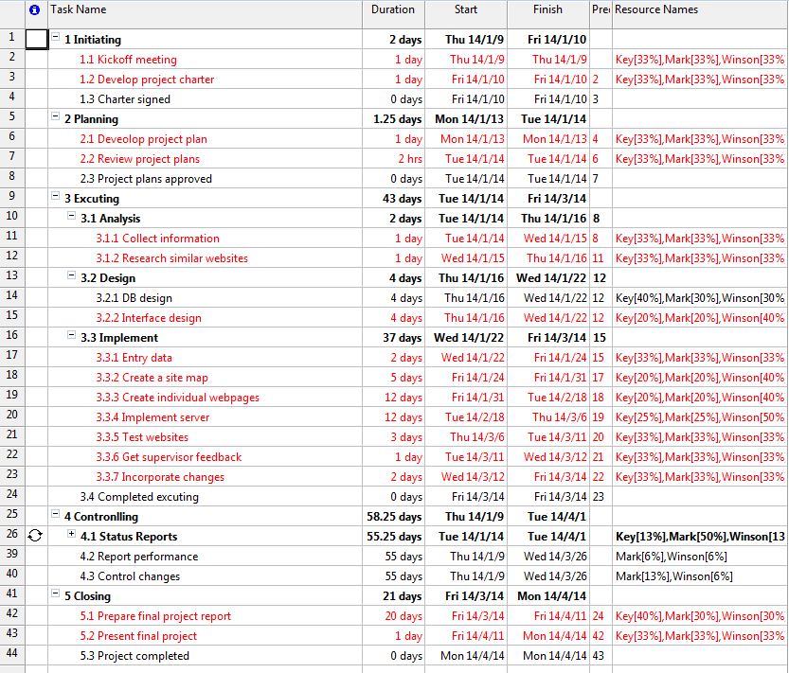

*Figure 21-1 Gantt Chat*

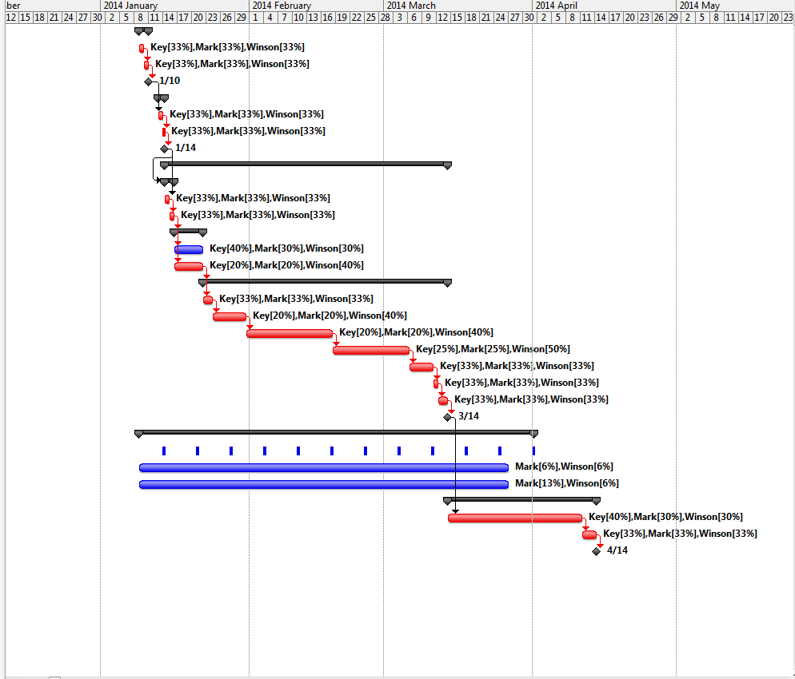

*Figure 21-2 Gantt Chat*

## Peer Assessment Form

|  |  |  |  |  |  |  |
| --- | --- | --- | --- | --- | --- | --- |
| S:\3rd ITC\2nd ITC\MPI_logos\MPI logo09_C349 CPE.tif  BSc. in Computing 2013/14  COMP321 Information System Implementation  Peer Assessment Form | | | | | | |
| Group number | 8 | | | | | |
| Group members | |  |  |  | | --- | --- | --- | |  | Student ID | Student name | | *1.* | P1107923 | LIANG Yijuan | | *2.* | P1104431 | MAK Chi Hou | | *3.* | P1104557 | WONG Weng Io | | *4.* |  |  | | 5. |  |  | | | | | | |
| Contribution **(**Each row must total to 100%) | | | | | | |
|  | | Member 1 | Member 2 | Member 3 | Member 4 | Member 5 |
| 1. Project leadership | | 100% | 0% | 0% | % | % |
| 2. Data modeling | | 45% | 40% | 15% | % | % |
| 3. User interface design | | 30% | 30% | 40% | % | % |
| 4. Program development | | 25% | 28% | 47% | % | % |
| 5. Solving technical problems | | 0% | 0% | 100% | % | % |
| 6. Testing and sample data | | 0% | 100% | 0% | % | % |
| 7. Report writing | | 35% | 30% | 35% | % | % |
| 8. Preparing / giving presentation | | 33% | 34% | 33% | % | % |

By default, the eight items above have the same weight when calculating the overall contribution percentage. You are welcome to suggest different weight if you consider some aspects should carry more weight.